

REQUEST FOR QUOTATION

RFQ-SMMU-30-2015 Date: 28/09/2015

The OSCE Special Monitoring Mission in Ukraine (SMMU) is looking for respective Contractor for the provision of Medical Trauma Kits.

The objective of the RFQ is to award a Local Window Contract (LWC) for a period of until March 31, 2016 with further prolongation up to 3 years that is subject depending on the suppliers’ satisfactory performance and extension of Mission’s mandate.
Proposals must be submitted in English or in Ukrainian or in Russian language.
Partial quotations submitted will not be accepted.

Any questions pertaining to this RFQ shall be addressed in writing, by email to the attention of Ms. Yulia Vizhol, Senior Procurement Assistant, Yulia.Vizhol@osce.org no later than 14:00 hours on 05 October 2015. Kindly refrain from telephone calls and personal visits.

Price Schedule

Items cost in the quotation shall include the price of items itself, packaging cost and delivery expenses based on DAP/DAT, Incoterms 2010. Address: 26 Turhenevska Street, Kyiv, 01054, Ukraine.

All prices shall be expressed in EURO without VAT, since the OSCE is exempt from taxes and duties.
In the case of submitting proposals in other currency, the price will be calculated in Euro in accordance with OSCE Exchange rate on the date of the offer.
The planned quantities to be ordered are specified in the tables below. In addition, there are possibilities of unplanned orders in various quantities as well as separately any item of requested sets throughout 2015 and 2016, depending on the suppliers’ satisfactory performance and extension of Mission’s mandate.

Please use the below stated planned quantities to be ordered to determine your prices and complete the pricelist.

The OSCE does not make any commitments to any purchase before placing a Purchase Order in place.

If any replacements took place, please make sure the item to be full analogy and marked in special way.

Quantities:

Purchase order planned for October 2015
Set name: | Quantity in peace’s
Personal Trauma Kits | 300
Team Trauma Bags | 130
Training items | Upon request

Price Schedule:

Set #: | Items | Order quantity in pcs. | Total Set Price in EURO excl. VAT
1. | Personal Trauma Kits
 |  | 10-50
 |  | 51-100
 |  | 101-200
 |  | 201-300
 |  | 301 - and more
2. | Team Trauma Bags
 |  | 10-50
 |  | 51-100
 |  | 101-200
 |  | 201-300
 |  | 301 - and more
3. | Training items
 |  | 10-50
 |  | 51-100
 |  | 101-200
 |  | 201-300
 |  | 301-and more

PERSONAL TRAUMA KIT /List of items

Requested ITEM | Substitute in case of requested item unavailability | Number of items in BAG | Cost per item due to q-ty diapason in EURO
Requested ITEM | Substitute in case of requested item unavailability | Number of items in BAG | 01-50 pcs | 51-100 pcs | 101-200 pcs | 201-300 pcs | 301 - and more
- CELOX HAEMOSTATIC GAUZE |  | 1
- COMBAT APPLICATION TOURNIQUET (C.A.T) |  | 1
- ISRAELI DRESSING 15 x 18cm |  | 2
- T4 TRAUMA DRESSING |  | 2
- BURNSHIELD DRESSING 100x100 |  | 1
- EASY FIX COHESIVE BANDAGE 10cm |  | 2
- TRIANGULAR BANDAGE |  | 1
- SP CPR MASK & CASE |  | 1
- ASHERMANS CHEST SEAL |  | 1
- SAM SPLINT |  | 1
- STERI STRIP |  | 1
- *TRAUMA BAG with Zip Fastener. Compact but can hold all the above items and be worn on the body. |  | 1
Pricing includes packing of kits and shipping costs (incoterms 2010) DAT/DAP airside Ukraine. |  |  | Cost of 1 (one) equipped bag within the price diapason.
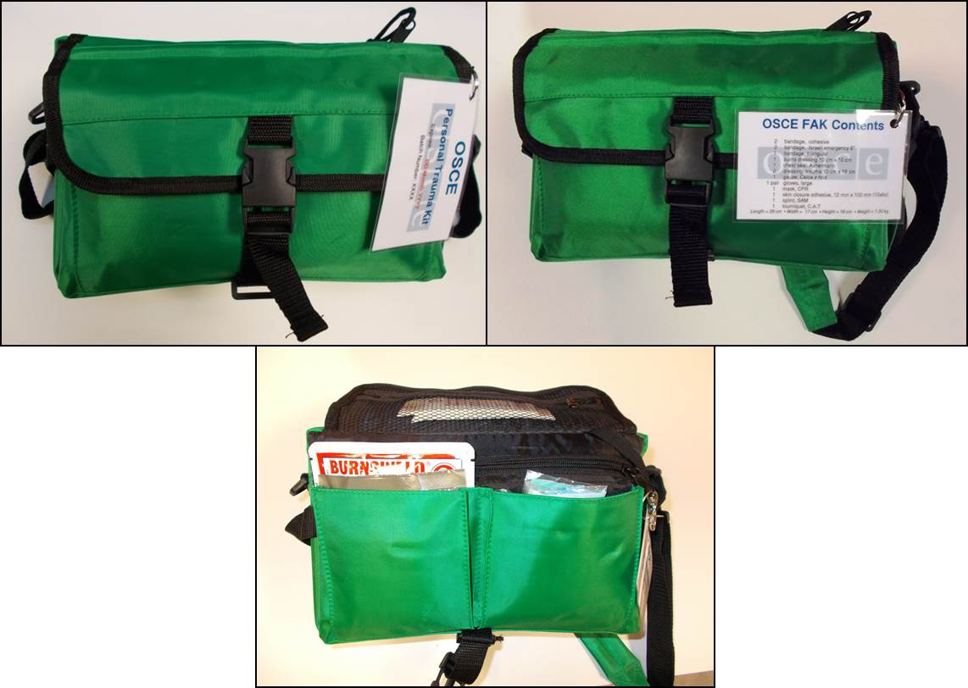

TEAM TRAUMA BAGS QTY/List of items

Requested ITEM | Substitute in case of requested item unavailability | Number of items in BAG | Cost per item due to q-ty diapason in EURO
Requested ITEM | Substitute in case of requested item unavailability | Number of items in BAG | 01-50 pcs | 51-100 pcs | 101-200 pcs | 201-300 pcs | 301 - and more
- Vent-Aid resuscitation shield |  | 10
- Penlight |  | 1
- SP CPR Mask & Case |  | 2
- Tisept sachets (Antibacterial liquid) |  | 1 Box
- Hand and body gel |  | 1
- Antibacterial wipes |  | 1 Box
- Micropore Tape (Use to attach dressings/bandages. Can be used for wounds) |  | 6 roll
- Tuf-cut safety shears |  | 1
- Combat Application Tourniquet (CAT) |  | 6
- Burnshield dressing 100 x 100 |  | 6
- Emergency foil blanket |  | 2
- Steri-strip | 2 x packs of x 5 | 10
- Disposable ice-packs (Activated as required.) |  | 2
- Nitrile Gloves (Box of 100) |  | 1 Box
- Celox Haemostatic Gauze |  | 6
- Israeli Dressing 15 x 18 cm |  | 8
- T4 Trauma Dressing |  | 8
- Easy Fix Cohesive Bandage 10cm |  | 8
- SAM Splint |  | 2
- Bandages (10x4,5 m) |  | 3
- Triangular bandages |  | 7
- Multi-absorbent dressing (30x45 cm) |  | 1
- Non-woven swabs (10x10 cm) |  | 3
- Ashermans Chest Seal |  | 4
25. Syringes 20 ml |  | 2
26. Syringes 10 ml |  | 2
27. Easy V dressings |  | 2
28. Solution administration set |  | 1
29. Blood infusion set |  | 1
30. Double sided dressings |  | 3 packs
31. Medium basic procedure packs |  | 2 packs
32. Sharp safe |  | 1
33. Adjustable Collar |  | 1
34. Trauma Rucksack (Robust design, high visibility materiel, shoulder straps.) |  | 1
35. Po-kit Stretcher |  | 2
Pricing includes packing of kits and shipping costs (incoterms 2010) DAT/DAP airside Ukraine. |  |  | Cost of 1 (one) equipped bag within the price diapason.
Team Trauma Bag sample
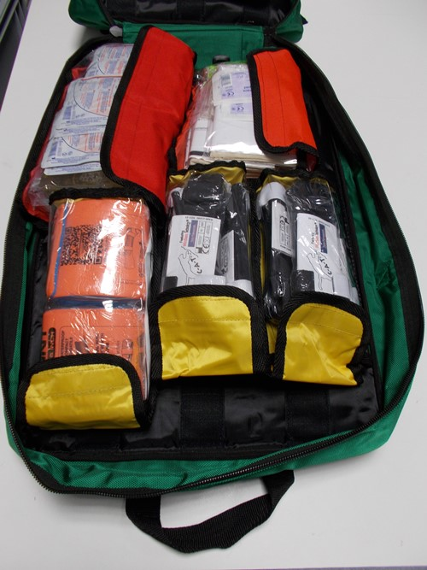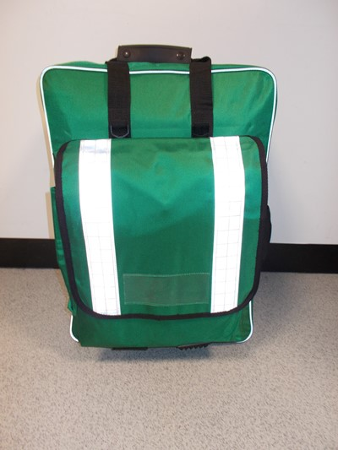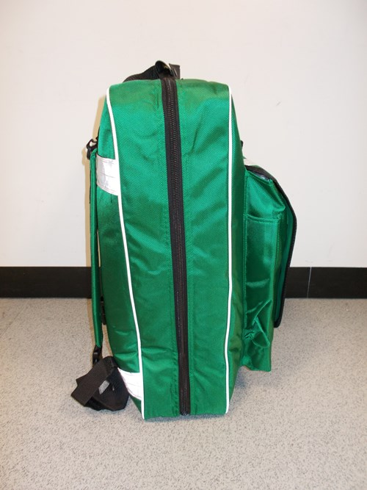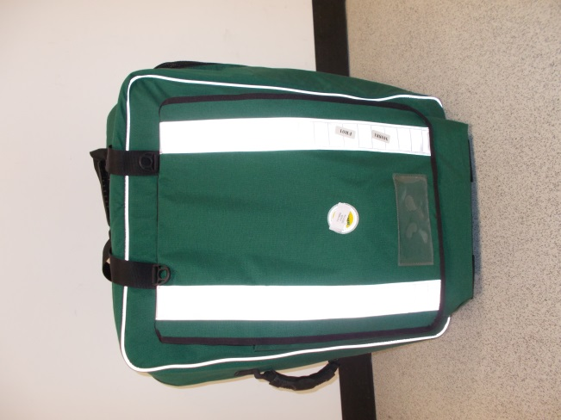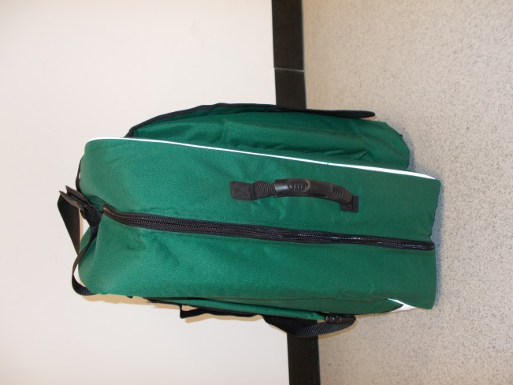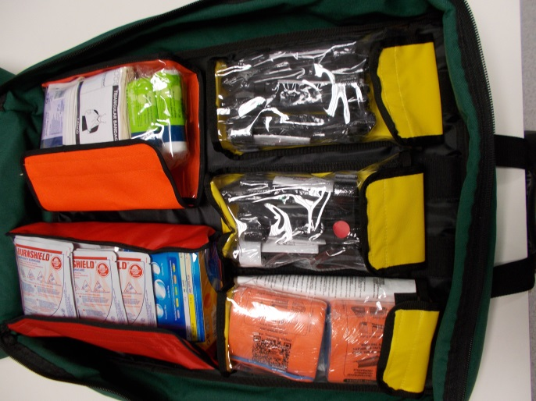

TRAINING ITEMS/List of items

Requested ITEM | Substitute in case of requested item unavailability | Cost per item due to q-ty diapason in EURO
Requested ITEM | Substitute in case of requested item unavailability | 01-50 pcs | 51-100 pcs | 101-200 pcs | 201-300 pcs | 301 - and more
CELOX HAEMOSTATIC GAUZE
COMBAT APPLICATION TOURNIQUET (C.A.T)
ISRAELI DRESSING 15 x 18cm
T4 TRAUMA DRESSING
BURNSHIELD DRESSING 100x100
EASY FIX COHESIVE BANDAGE 10cm
TRIANGULAR BANDAGE
ASHERMANS CHEST SEAL
SAM SPLINT
STERI STRIP
Tisept sachets (Antibacterial liquid)
Hand and body gel
Antibacterial wipes
Micropore tape
Nitril Gloves (Box of 100 = 50 pairs)
Pro-Kit Stretches
Pricing includes packing of kits and shipping costs (incoterms 2010) DAT/DAP airside Ukraine. |  | Cost of 1 (one) equipped bag within the price diapason.

Any Purchase Order will be subject to the OSCE General Conditions of Contract which can be viewed at http://www.osce.org/procurement. Detailed “Instructions to Bidders – Request for Quotation” are also provided on this website.

Deadline for submission of quotations: 09/10/2015; 14:00 (Kyiv time)

Payment terms: post payment after cervices receipt within 30 working days

Validity of offer: 30 days min.

Terms of Cooperation: Local Window Contract

Company name: ________________________________
Authorized representative’s name and signature: ________________________________
Address: ________________________________
Email: ________________________________
Telephone: ________________________________

QUOTATIONS SHALL BE ADDRESSED TO: tenders-smmu@osce.org

Vendors who are not registered with OSCE need to complete the Vendor Registration Form, that is attached or can be finding on http://www.osce.org/procurement.

