Date: 28 February 2018
Clarification Note No. 1

Invitation to Bid No. ITB/SEC/01/2018
Provision of Flags to the OSCE

The Organization for Security and Co-operation in Europe has received request for clarifications from potential bidders. In accordance with Article 18 of the ITB Document, the OSCE would like to provide the following clarification:

Question 1:
With reference to the table flags, would a metal stand instead of a wooden stand be acceptable?

Answer 1:
Only wooden stands in accordance with our technical specifications are acceptable.

Question 2:
With reference to the nation name at the top left corner of the national flag. Is the nation name required to be printed on the flag?

Answer 2:
The nation name should not be printed on the flag, it should only be on a label attached (sewn) to the flag as per following picture:

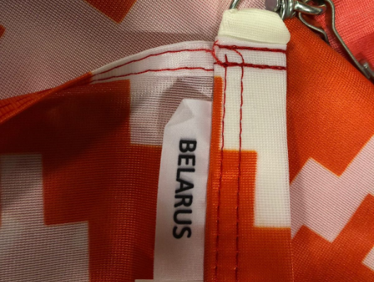

Question 3:
Can you provide us with the OSCE logo?

Answer 3:
The OSCE logo for printing purposes will only be provided to the winning company.

Question 4:
Will the company be disqualified by offering screen printing instead of digital printing?

Answer 4:
Offering screen printing will not be a reason for disqualifying the company but this might have an impact on the prices and eventually on the contract award.

