

REQUEST FOR QUOTATION
Except as provided in the Amendment below, all other requirements of the tender shall remain unchanged.

Ref.: RFQ-KYR-20-031 Amendment No.1 Date: 15 Apr 2020

Subject: Supply of video recording equipment for the Jogorku Kenesh.

The OSCE Programme office in Bishkek has a requirement for supply for the item(s) listed below and kindly requests you to provide a quotation as follows in compliance with the Terms and Requirements (Annex I). Interested companies are invited to submit a quotation.

QUOTATIONS SHALL BE ADDRESSED TO: tenders-poib@osce.org

Deadline for submission of quotations: 29 May 2020, 17:00 p.m. (Bishkek local time UTC+6)

A mandatory PHYSICAL SITE VISIT is scheduled on 14 of May 2020 at 10:00 Bishkek time. No VIRTUAL SITE VISIT will be arranged.

To comply with the formalities required to visit the facilities, provide the name and passports of the representative (s) of your company no later than 15:00 local time on 12 May 2020 to Aigul Zhusupova, Aigul.zhusupova@osce.org

Vendors who are not registered with OSCE need to complete the Vendor Registration Form http://www.osce.org/procurement and to submit it together with supporting documents, i.e. copy of business registration and licenses. Annex II

Please use this form for the submission of your quotation. Additional information can be supplied on a separate page.

Only completed quotes would be considered for evaluation.

Item No. | Description | Qty | Unit Price  DAP | Extended Price  (excl. VAT)
 | Broadcast PTZ camera | 4
 | Remote camera control panel | 1
 | Broadcast digital video mixer | 1
 | Control monitor | 2
 | Hardware and software set for recording | 1
 | Full set of cables (to be calculated by Contractor) | 1
 | Installation/testing | 1
 | Training | 1
 | TOTAL (currency) DAP
 | VAT (if applicable)
 | TOTAL (currency) DDP

Any Contract or Purchase Order will be subject to the OSCE General Conditions of Contract which can be viewed at http://www.osce.org/procurement. Detailed “Instructions to Bidders – Request for Quotation” are also provided on this website.

Delivery time and terms: DDP (INCOTERMS 2010) - 6, Ryskulov str., Bishkek, Kyrgyzstan, maximum 60 days after order in place.

Payment terms: 30 days net
Validity of offer (60 days minimum): .… Please indicate here the period of validity of your bid ……….
Company name:
Authorized representative’s name and signature:
Address:
Email:
Telephone:
Annex I

COMMON QUALIFICATION REQUIREMENTS

 | Common minimum qualification requirements of the supplier (company) | To be filled by the tenderer  (compliance/non-compliance to the stated requirements)
 | The supplier must be registered as a legal entity or an individual entrepreneur in accordance to the legislation of the country of registration; a brief description of the company and copies of registration documents should be attached to the proposal | Provide short company presentation to demonstrate compliance to the requirement. Attach registration certificate, statutes.  Indicate here the available licenses if required by local legislation. Attach copies of the respective licenses
 | The supplier should have a minimum experience in the field of supply/ production of relevant goods not less than 3 years, upon request provide at least 2 feedbacks from previous customers | Provide short description of the portfolio, indicate at least two references for which services of a similar size and complexity as stated within this tender document have been provided within the last three years.
 | Any potential supplier should not be declared bankrupt, liquidated or become insolvent, or in case a bankruptcy procedure has been initiated against a supplier, the OSCE has the right to reject its quotation. The supplier is obliged to immediately inform the OSCE about the occurrence of any of the above events;  The supplier should not be involved or have open litigation related to complicity with terrorism and extremism, illegal money laundering. | State lack of litigation history or specify the litigation processes involved in currently or in the past and the nature of the cases
 | The supplier should not be in tax arrears and other obligatory fees in accordance with the requirements of the legislation of the country of its registration | Please indicate here compliance/non-compliance to the stated requirement

TECHNICAL SPECIFICATIONS AND SCHEDULE OF REQUIREMENTS

NB: all goods and materials to be incorporated into the Goods must be new, unused, and of the most recent or current models, and that they incorporate all recent improvements in design and materials unless provided for otherwise in the Contract.

Background
Under the Project Support to Strengthening Democratic Governance in Kyrgyzstan, the OSCE Programme Office in Bishkek (POiB) actively co-operates with the Jogorku Kenesh and supports its efforts aimed at enhancing efficiency, transparency, accountability and public outreach of Jogorku Kenesh. For this purpose, the POiB plans to purchase the equipment to the national Parliament, which will provide technical solution to stream the sessions of Parliament in Internet and on television as well as record it for archive.

Objective
The objective of the contract is to purchase of the equipment which will ensure free public access to online resources and broadcasting of parliamentary sessions.
Namely, under the said contract supply and installation of the live TV broadcast system with equipment for video images storage and archiving is envisaged. The set of required equipment should include:
- Broadcast PTZ cameras;
- Remote camera control panel;
- Broadcast digital video mixer;
- Control monitors;
- Hardware and software set for recording;
- Cable materials.

Description of the existing network and facilities
Currently, the Jogorku Kenesh of the Kyrgyz Republic is equipped with a similar system in the main hall, which allows both live broadcasting of meetings of the Parliament of the Kyrgyz Republic and recording video materials taking into account their long-term storage. The specified system is as versatile as possible - it allows to simultaneously broadcast the Internet, as well as through broadcasting on television channels of the Kyrgyz Republic. In addition, the system allows, if necessary, to quickly transmit videos for various media, if they cannot provide operators for independent filming.
Considering the experience of creating the existing multi-chamber broadcasting system, it is planned to equip small halls with similar equipment to perform tasks related to the shooting, recording and broadcasting of meetings of committees and factions of deputies of the Parliament of the Kyrgyz Republic. Although the set of equipment for the planned system is identical to the equipment already used in terms of components, the equipment itself, of course, was selected taking into account new tasks: the size of small rooms is much smaller than the size of the main conference room; the number of deputies participating in the committee meetings is less than the number of deputies in the meetings of the Parliament of the Kyrgyz Republic - this has already removed some restrictions on equipment of broadcasting quality, the “average” price range, which was impossible to use in a large conference room, but could be used in this project. When testing cameras from the "average" price category, there was an unsatisfactory quality of material. Thus, based on previous experience and because of the limited budget, the inability to select cameras and optics from the “high” price range, cameras were selected from the “average” price range, but with the ability to shoot in 4k format, which with more sensitive matrices, somewhat eliminates problem coverage in small committee rooms.
We emphasize that the requested equipment must be of broadcast quality and intended for television broadcasting. It is imperative to exclude offers with equipment designed for video surveillance. Although at first glance video surveillance equipment has similar characteristics, the purpose of its use is completely different.
The required equipment should record exactly the video image, since in the classical scheme of studio recording, all sound is recorded separately, on separate devices that are available. Required equipment will be integrated with sound system only. The technical characteristics of the requested equipment are designed in such a way that, in full compliance, the new video recorders are successfully integrated with existing sound devices. It is possible to organize site visit to the Parliament premises upon advance scheduled appointment.

System diagram
The Contractor is going to ensure proper communication of the all components of new system. (See the item specification in the “Technical Requirements Grid” section)

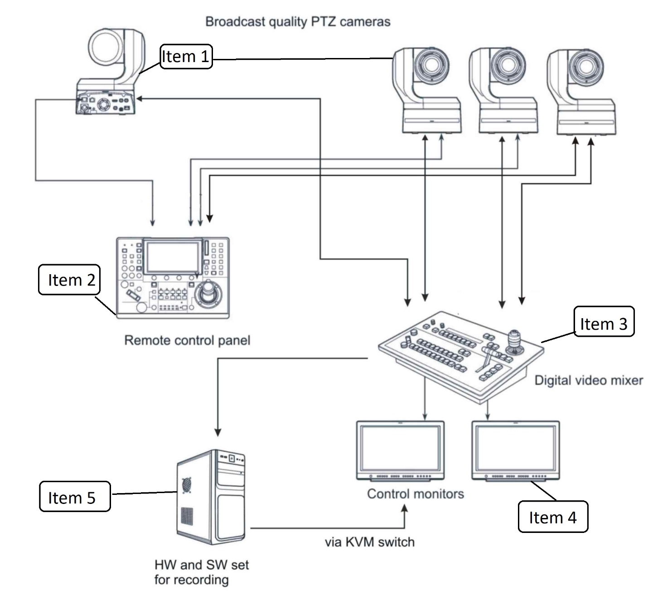

Western small Hall of the Parlament
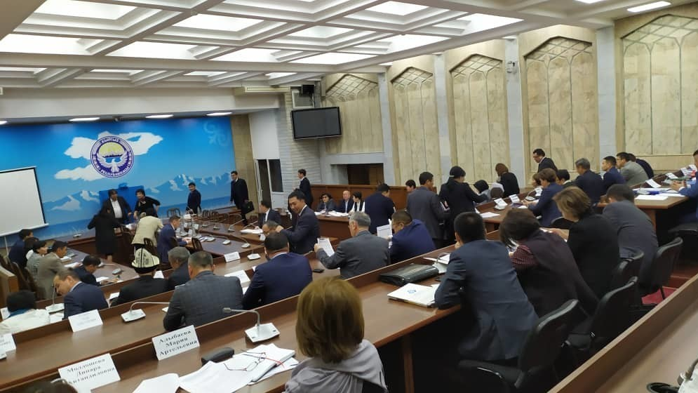

Scheme of premises
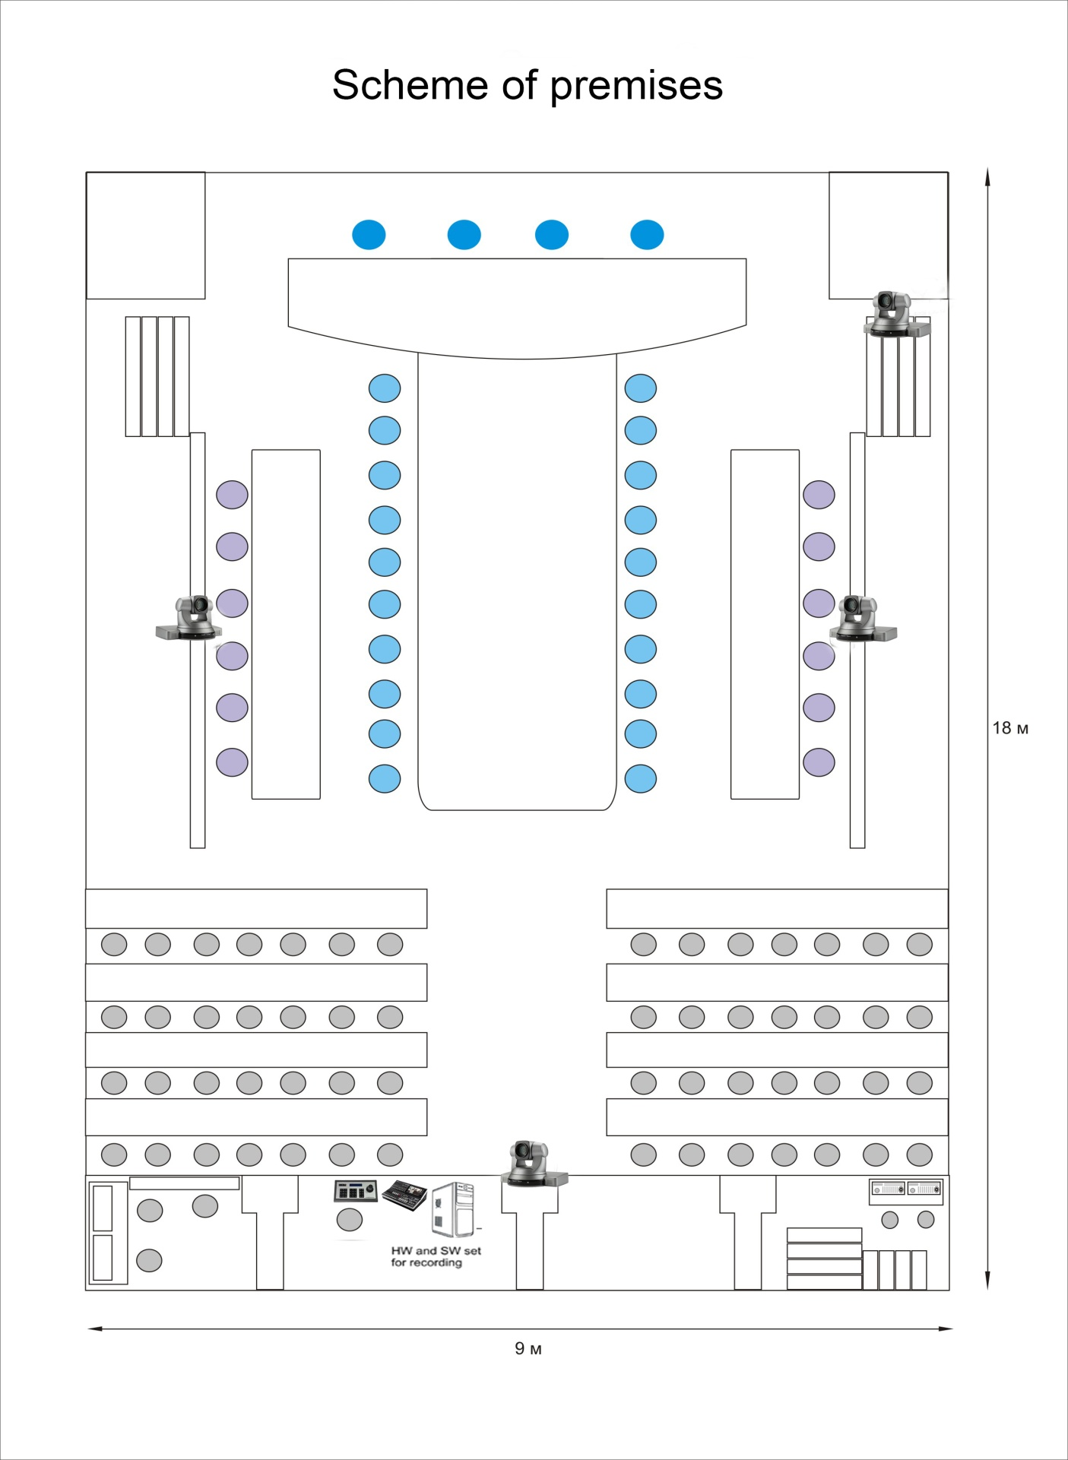

List of supplies to be provided
- Broadcast PTZ camera – 4pcs;
- Remote camera control panel – 1pc;
- Broadcast digital video mixer – 1pc;
- Control monitor – 2pcs;
- Hardware and software set for recording – 1set;
- Full set of cables (to be calculated by Contractor)

The equipment to be supplied under the contract must be exactly or better as per provided Technical specifications. The delivery should include installation, configuration, testing of components, as well as the entire system, taking into account integration of the system with the existing audio part. Warranty requirement is at least 36 months from the installation date.

The equipment must be delivered to the following address: Jogorku Kenesh (Parliament) of the Kyrgyz Republic 205, Chuy str. 720003 BISHKEK KYRGYZSTAN, installed and put into operation. After that contractor must provide training for three persons of Parliament technical staff.

Technical requirements grid
Item # | Technical Specifications/Description of items | Quantity | Compliance Remarks  The Bidders are required to specify make/model and put item-by-item commentary on the Technical Specifications demonstrating substantial responsiveness of the Goods to those specifications, or a statement of deviations and exceptions to the provisions of the Technical Specifications.
1 | Broadcast PTZ camera
1 | Broadcast PTZ camera  NOT FOR video surveillance | 4
1.1 | Signal system: 4k 3840x2160; 1080p 50/60; 1080i 50/60; 720p 50/60 (4k/UHD/FHD)
1.2 | Sensor resolution: not less than 11MP
1.3 | Zoom: motorized, not less 30x optical zoom
1.4 | FOV: minimum range horizontal: 60grd – 1.5grd
1.5 | Min focus distance: not more 80cm (wide); not less 80cm (telephoto)
1.6 | Movement (min) range: +/-170grd; -30…+90grd
1.7 | Focus control: auto/manual
1.8 | Iris control: auto/manual
1.9 | Min illumination: no more than 0.35lux
1.10 | Remote control: Pan, tilt, zoom, focus, iris, shutter
1.11 | Connections: HDMI, 3G/HD/SD SDI
1.12 | Remote control: VISCA; IP; RS-422/RS-232
2 | Remote camera control panel
2 | Remote camera control panel  NOT FOR video surveillance | 1
2.1 | Qty of the cameras to control simultaneously: up to 251
2.2 | Min qty of the cameras to choose by the fast access buttons: 5
2.3 | Control: Pan, tilt, zoom, focus, iris, shutter
2.4 | Control protocols: IP/VISCA/RS-422/RS-232
3 | Digital video mixer
3 | Digital video mixer  NOT FOR video surveillance | 1
3.1 | HD/SD SDI video mixer
3.2 | Video inputs: up to 12 HD/SD SDI; up to 3 HDMI
3.3 | Video outputs: min 4 HD/SD SDI; min 2HDMI
3.4 | Integrated preview with multi-screen feature
3.5 | Audio inputs/outputs: 4/2XLR
3.6 | Functions: Audio delay, PiP, Logo, transition, chromakey, DSK, Genlock
4 | Control monitor
4 | Control monitor | 2
4.1 | 21.5” ordinary computer monitor with HDMI input
4.2 | resolution: FHD, 1080i/1080p
5 | Hardware and software set for recording
5 | HW and SW set for recording | 1
5.1 | Computer station (Core i7 s1151/32Gb RAM/500Gb SSD + 2x8Tb HDD 7200RPM/Video GT1030 HDMI / Keyboard, mouse)  - Video board with SDI/HDMI video inputs/outputs (broadcast quality)  - Multichannel interface PCIe x 8; 8 independent SDI-interfaces will maximize qty of video and audio connections; must support all formats camera above can provide;  - 2port KVM switch (HDMI/USB) to use control monitor with video mixer and with recording set as well | 1
5.2 | MS Windows 10 Professional | 1
5.3 | Recording software license  - must support all the listed hardware  - must have minimum 8 video inputs  - must work with all abovementioned camera resolutions  - must have min 4 overlay channels  - must record input signals with different video formats AVI/MP4/H264/ MPEG-2/MOV and different levels of compression with tuned bitrates | 1
5.4 | license must be for lifetime, NOT by subscription service
6 | Cables
6 | Set of quality broadcast cables
6.1 | Exact qty of cables must be calculated by supplier according to provided equipment. Local site where equipment will be installed can be reviewed by supplier. Must contact and schedule appointment in advance.
7 | Installation, testing, training service
7.1 | Installation | 1
7.1.1 | The Contractor must install all supplied equipment according the system diagram provided.
7.1.2 | The Contractor must setup all supplied equipment to receive SDI video from each camera on dedicated channel on video mixer in real time; besides every camera can be controlled by Control panel.
7.2 | Testing | 1
7.2.1 | The contractor must perform tests for all installed equipment. Testing must include only subject testing:
7.2.2 | Each camera must comply technical specifications requested
7.2.3 | Each camera must performs zoom up to 30x (optical)
7.2.4 | Each camera must follow requested movement range
7.2.5 | Focus must be controlled
7.2.6 | Iris must be controlled
7.2.7 | Pan, tilt, zoom, focus, iris, shutter must be controlled remotely
7.2.8 | Image from each camera must be clear and must be close to reference image.
7.2.9 | Remote control panel must control Pan, tilt, zoom, focus, iris, shutter of each camera
7.2.10 | Digital video mixer must performs Audio delay, PiP, Logo, transition, chromakey, DSK, Genlock
7.2.11 | Digital video mixer must performs preview with multi screen
7.2.12 | HW and SW set must record input signals with different video formats AVI/MP4/H264/MPEG-2/MOV and different levels of compression with tuned bitrates
8 | User training
8 | User Training | 1
8.1 | Training must be completed after passing the system to tests
8.2 | Training will be conducted in Russian or English with translation to Russian
8.3 | All training materials will be translated in Russian
8.4 | Training will take place in Bishkek in premises of National Parliament
8.5 | User training for 3 persons
8.6 | Costs of training, reference materials, equipment and lecturers will be covered by the Contractor
8.7 | Min. scope of training includes:  - Operating all devices,  - Monitoring their status,  - Troubleshooting the system,  - Video signal quality and transmission basics,  - Video signal conversions,  - Maintaining connections in the system,  - Ensuring high quality of video signals
9 | Warranty
9.1 | At least 36 months from the installation date

Signature and seal of bidder: ____________
Vendor Registration Form
Annex II
Company Contact Details and General Information
1. Name of Company:
2. Street Address: |  | City: | Postal Code: | Country:
3. Mailing Address and P.O. Box:
4. Telephone Number:
5. Fax Number:
6. Website:
7a. Contact Name (for Bids):
7b. Contact Title:
7c. Contact email address:
8a. Contact Name (for Contract signature, if different to point 7 above):
8b. Contact Title:
8c. Contact email address:
9. Parent Company, if any (full legal name):
10. Principal subsidiaries, associates, and/or representative(s), if any:

11. Corporate Seat:

Section 2: Company Profile
1. Type of business | (Corporate/Limited, Partnership, Private Firm, Family Business)
2. Nature of business: | (Manufacturer, Authorised Agent, General Trader, Consulting Firm)
3. List of authorized products
4. Year established
5. Number of full time employees
6. License number and Country where registered:
7. Tax / VAT ID Number:

Section 3: Financial Information and Experience
1. Annual value of total turnover for the last three years:
2016 |  | 2017 |  | 2018
2. Annual value of the working capital (profit) for the last three years:
2016 |  | 2017 |  | 2018

3. Contracts of similar scale/volume during the last three years:
Customer Name | Value (EUR) | Year | Goods and Associated Services Provided | Country

4. Three (3) customer references:
Company Name | Contact Name | Position | Contact email | Contact telephone

Section 4: Technical Capacity and Information on Goods/Services offered
Description of core goods / services offered:
1.
2.
3.
4.
5.
6.
7.

2. Quality Assurance Certification Number:
3. Membership of International Trade or Professional Organisations:

Section 5: Banking details
1. Name of Bank:
2. Account Number:
3. Account Name: Must be in the name of the vendor
4. BIC:
5. IBAN:

Corporate Stamp and Signature of
Authorized Representative of Contractor:

Name:…………………………………………………….

Signature:………………………………………………

Date:………………………………………………………

