REQUEST FOR QUOTATION

Ref.: RFQ/KOS/620286/2021
Subject: Provision of creating a showroom (corner) at KAPS for presenting public safety education history throughout its development phase (1999-2021)
The OSCE Mission in Kosovo (hereinafter called “the OSCE”) invites you to submit your quotation as per Technical Specifications (hereinafter called “the Goods”) as specified in this Request for Quotation and its attachments (hereinafter called “the RFQ Documents”). Interested companies are invited to submit a quotation.
NOTE:
- QUOTATIONS SHOULD BE ADDRESSED TO: Tenders.omik@osce.org clearly marked with the RFQ reference number and title. (please do not use email address: procurement.omik@osce.org for submission of quotations)
- QUERIES FOR CLARIFICATION SHOULD BE ADDRESSED TO: procurement.omik@osce.org (kindly note that queries and matters for clarification are accepted until 11 October 2021 - CoB). INTERESTED BIDDERS SHOULD REGULARLY VISIT
https://procurement.osce.org to get updated with any CLARIFICATION, AMENDMENT, EXTENSION issued on the RFQ, during the process
- DEADLINE FOR SUBMISSION OF QUOTATIONS: On or Before 15 October 2021 at 12:00 hrs (CET) LATE QUOTATIONS AND QUOTATIONS SUBMITTED TO OTHER EMAIL/ADDRESS WILL BE REJECTED
- Upon receipt of this RFQ, you are kindly requested to return the attached Acknowledgement Letter (Annex F) as soon as possible to Procurement.OMiK@osce.org, advising whether your company intends to submit a quotation.

This Request for Quotation (RFQ) consists of the following annexes:
Annex A: Qualification Information Form
Annex B Terms of Reference and Technical Specifications
Annex C: Detailed Dynamic Plan for Implementation of the required Works
Annex D: Pricing Format-Bill of Quantities
Annex F: Acknowledgment Letter

SITE VISIT
- To be organised only if requested by the potential bidders.
- The personnel present at the Kosovo Academy for Public Safety (KAPS) premises during the site visit shall respect the COVID19 preventive measures at all time.

Deadline for submission of quotations on or before: 15 October 2021 at 12:00 hrs (CET).
Any Contract or Purchase Order will be subject to the OSCE General Conditions of Contract which can be viewed at http://www.osce.org/procurement. Detailed “Instructions to Bidders – Request for Quotation” are also provided on this website.
Delivery time (please specify): _________________________ days
Delivery terms: DAP (INCOTERMS 2010) - OSCE MIK Warehouse, Fushe Kosove/Kosovo Polje 12000, Kosovo
Payment terms: 30 days net
Validity of offer (60 days minimum): ________________________
Company name:
Authorized representative’s name and signature:
Address:
Email:
Telephone:
(Stamp)

Annex A: Qualification Information Form

General Information
1. Bidder’s Full Legal Name:
2. Street Address: | Postal Code: |  | City: | Country:
3. P.O. Box and Mailing Address:
4. Telephone Number:
5. Fax Number:
6. E-mail Address:
7. Web-site Address:
8a. Contact Name:
8b. Contact Title:
9. Corporate Seat:
10. Type of Business:
11. Year Established:
12. Number of Staff Employed:
13. Parent Company, if any (full legal name):
14. Principal subsidiaries, associates, and/or representative(s), if any, that are relevant to the Services:
Financial Information
15. For the last three financial years:
Year | Turnover (EUR) | Working Capital (EUR)
Experience
16. Contracts of similar scale/volume during the last three years:
Customer Name and Contact Details | Value (EUR) | Year | Services Provided | Country

Banking details
1. Name of Bank:
2. Account Number:
3. Account Name: Must be in the name of the vendor
4. BIC:
5. IBAN:

Corporate Stamp and Signature of
Authorized Representative of Contractor:
Name:…………………………………………………….
Signature:………………………………………………
Date:………………………………………………………

Annex B: Terms of Reference

Provision of creating a showroom (corner) at KAPS for presenting public safety education history throughout its development phase (1999-2021)

- Background

The OSCE Mission in Kosovo (OMIK), through its Special Advisory Unit (SAU) - Department for Security and Public Safety (DSPS) – is planning to support the Kosovo Academy for Public Safety (KAPS) on creating a showroom. With the aim to promote the educational and development phases of law enforcement institutions over the last 20 years, as well as promote the support given by the international community on creating democratic law enforcement agencies, the KAPS management has asked the Mission for support in creating a showroom/corner within its facilities, as seen in many modern police academies/colleges around the Europe. This corner will be developed to present uniforms, equipment and other law enforcement items to the local and international delegations visiting KAPS. It will also contain a photo-shooting place to be used by children from primary and secondary schools who visit the academy and other youngsters from all around Kosovo who use the facilities for social events. This way, the community engagement will help KAPS to attract youth, strengthen co-operation with law enforcement providers, build their trust in police and improve exchange of information with police by addressing different threats related to their age.
Electrical installations need to be spread with plastic tubs and channels to the intended locations not to create damages on the new building.

- Scope of Services / Technical specification

- The show room with be placed at the ground floor at the open area (multipurpose area) next to the conference room to be more visual and accessible to the visitors.

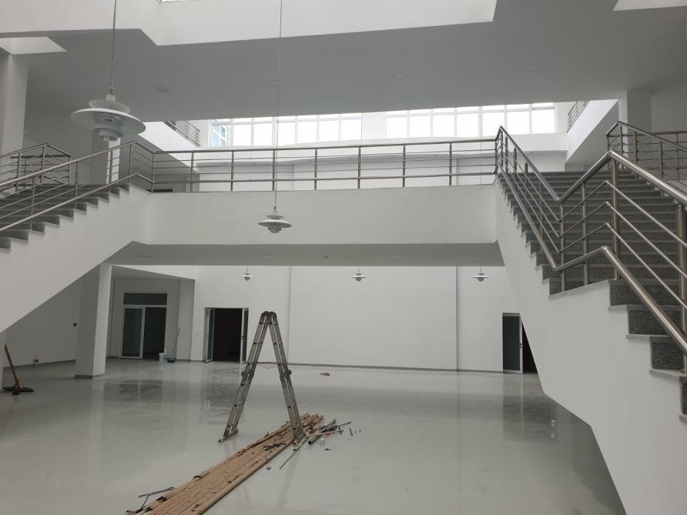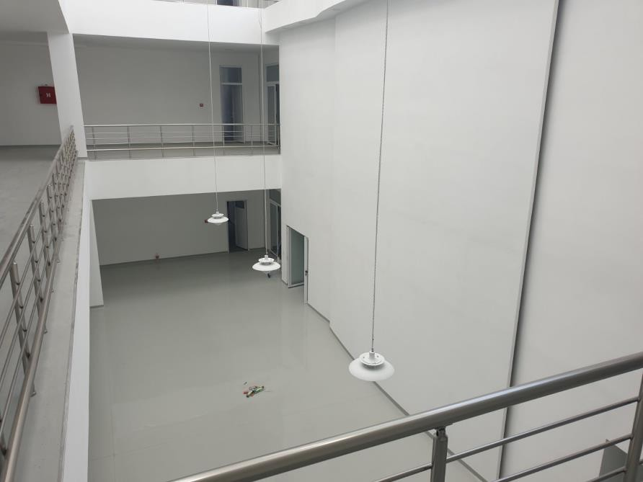

- Showroom

As the academy represents several agencies they are more than 10 different uniforms starting from cadets to the specialized ones. An area where the visiting school kids can gather and hear the presentation also interact with the items needed to be designed. At the entrance all the history materials with be placed as a starting point for the showroom. Because of the layout on ground floor the uniforms where divided in groups as: Official uniforms and specialized ones. In the middle two (three with the K9 dog statue) uniforms will be presented without the boxes together with and seating area. This part will be covered with a carpet to be more representative and more suitable to kids.

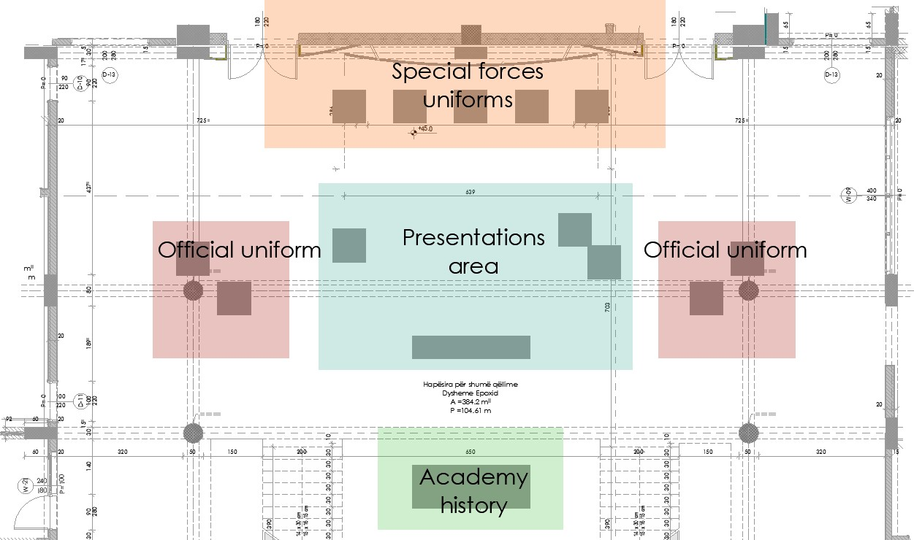

- Technical Specification of the items to be purchased

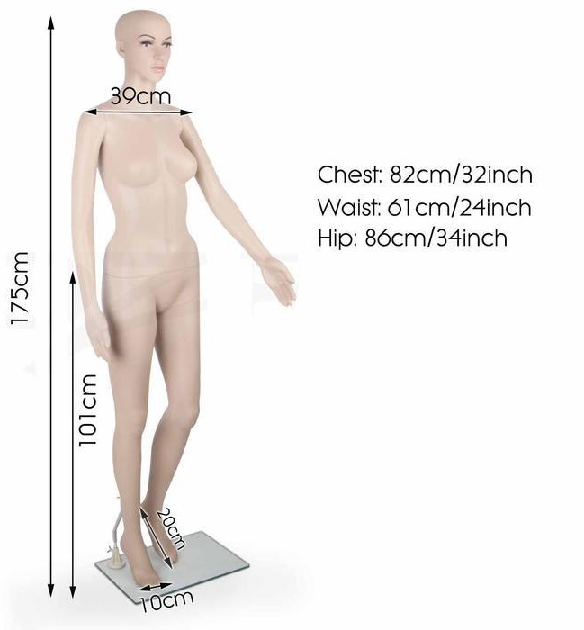
- Dimension and physical appearance of the mannequins.
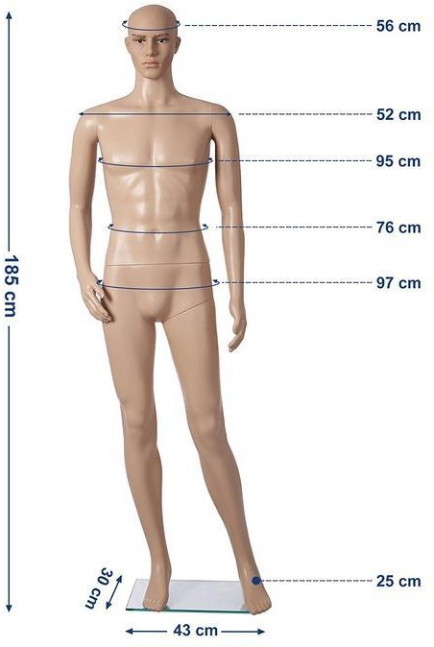

- Spot lights for the show room

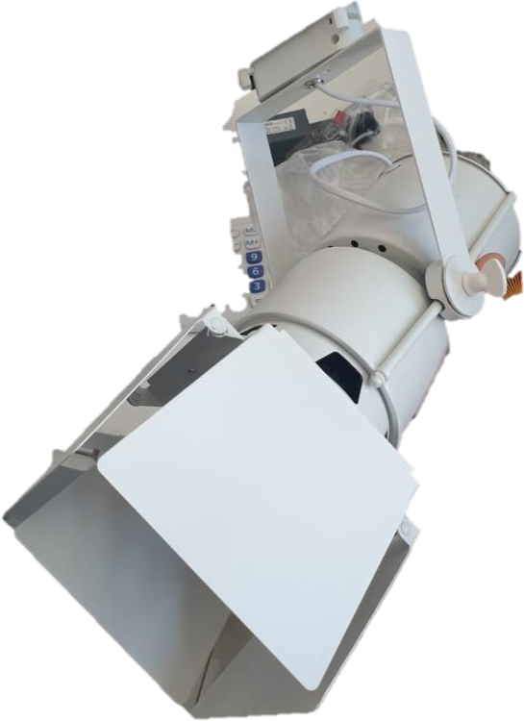

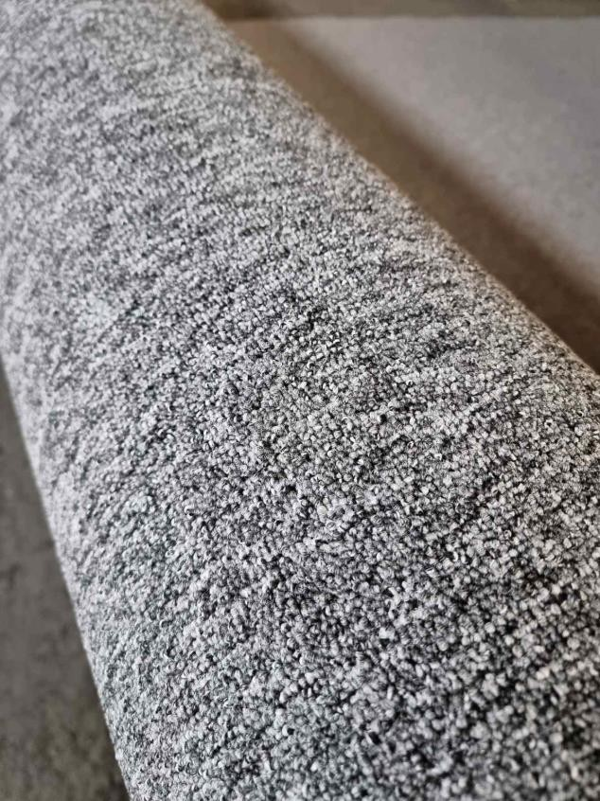
- Carpet for the presentation area

- Walnut wood furnish.

- Glass options, 8 mm or tempered 6 mm glass.
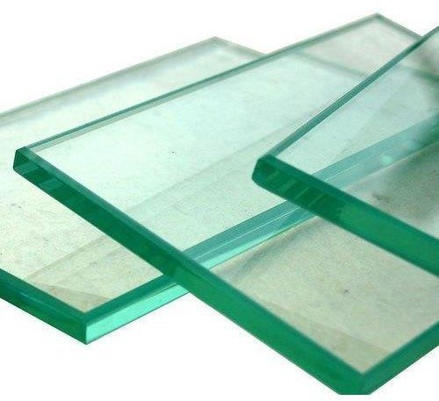
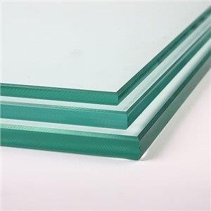

- Site Visit

- To be organised only if requested by the potential bidders.
- The personnel present at the Kosovo Academy for Public Safety (KAPS) premises during the site visit shall respect the COVID19 preventive measures at all time.

- Expected Deliverables
- By 29th of October 2021.

- Key Performance Indicators
- Completing the purchase, supply, construction / installation of any material positioned under the project and testing of materials is necessary before issuance of work.

- Time Frames and Proposed Fees
- Delivery should be done during the working days: (8.00 – 16.00 hours).
- The personnel present in KAPS premises shall respect at COVID19 preventive measures at all time.
- Delivery should be done by 29th of October 2021.
- Payment to vendor will be made upon the conclusion of services.

- Requirements for the Bidder
- The contractor is a well-established, company with min. 3 years’ experience in the services related to maintenance of the buildings.
- The contractor shall have relevant technical knowledge (qualified technicians) and shall be duly authorized /registered/licensed to provide the required Services.

- Evaluation Methodology

Least Cost Selection:
Each quotation will be evaluated on the basis of its responsiveness to the Terms of Reference contained in the RFQ Documents by applying the “fail/comply” evaluation criteria as per below specified criteria:
- Company profile: at least three years of relevant experience in in the services related with central heating service and maintenance:

- Relevant qualification: The contractor shall have relevant technical knowledge (qualified technicians) and shall be duly authorized /registered/licensed to provide the required Services.
A quotation shall be rejected at this stage if it fails to meet any or several of the requirements specified on the TOR
Award will be made to the Bidder whose quotation is the lowest priced one among those that pass the minimum technical score.

- Technical Compliance Form

Note to Bidders: The Bidders shall complete the table below by putting an item-by-item commentary on the OSCE’s requirements, providing detailed description and attaching necessary supporting documents to demonstrate responsiveness to the requirements.

ToR Ref. | Requirements/Specifications | Compliance Remarks and Description  Please confirm compliance and provide additional remarks and description, as appropriate.
 | Requirements for the bidder
1 | Supply, transport and installation of glass boxes for display of uniforms, MDF base (or similar) and wheels for moving. One side needs to be with hinges and a key lock to security.  Drawing DS01 Dim. 85x85x225 cm  8 mm glass or tempered glass.
2 | Supply, transport and installation of presentation shelfs as per design. The cabins need to be made from glass and wood with walnut furnish. DS02, DS03, DS04.
3 | Supply and transport of K9 dog life size statue that will be set on the presentation area.
4 | Supply, transport and installation of spot lights for the case displays.  The lights will be installed on the beam around the showroom on the first floor. The installation needs to be done with a rail and the lights should be accountable as the boxes will be moved as needed.  Specifications:  LED light  At least 35 w 4000 K  100Lm/w  Flux: 3850 lm
5 | Impression book
6 | Supply and installation of reading materials for the  showroom:  -Writing on the walls  -Explanation cards in three languages  -Posters
7 | Supply and installation of electrical cabling for the lights system together with all accessories. Tubes, switches, etc.
8 | Supply of material and installing of carpet on the floor at the presentation area:  Manufacturing process Tufting 1/10” Looppile Pile content  100% PP Stainsafe® Primary backing Woven PP Secondary backing synthetic backing Fire class  Dfl-s1(EN13501-1)
9 | Supply and transport of mannequins (display dolls) for presentation of the uniforms. 6 male and 5 female. The body should be completed with face and torso and if possible hair on the head. The base should be rugged because of the weight of uniforms.

- Minimum Qualifications of Bidder
8.1 The contractor should be a well-established company with minimum three (3) years of experience in the respective field of construction work. Documents of proof are required to be submitted with the quotation like:
    - At least three (3) Reference letters from similar/relevant engagements (stamped and signed from client);
    - Banks statement of the company for the past three years;
    - List of company employees for the last three years provided and stamped
from the authorised relevant institutions (Kosovo Tax Administration);
    - Proof of machinery that company has under possession (copies of machinery and vehicle registration licenses)
8.2 The contractor should have relevant technical knowledge and shall be duly authorized /registered/licensed to provide the required Services.
8.3 The contractor should assign a qualified and experienced staff in implementation of this project. Project manager proposed, should be contractors staff with at least three years relevant work experience. Contractor should submit with their quotation:
    - A proof that the proposed project manager is contractors core staff (i.e. work contract of project manager)
    - CV of project manager, that will manage this project/contract;
    - Copy of diploma/s and reference letters for project manager that proof for at least past three years in this field of work.

- Evaluation Methodology

Least Cost Selection Comply/Fail:
Each quotation will be evaluated on the basis of its responsiveness to the technical requirements contained in the RFQ documents by applying the “fail/comply” evaluation criteria as per below specified criteria:
- Specific Experience and knowledge in the field; based on the proof/presented documents as required under section VIII/point 8.1 of this document;
- Qualification and experience of the proposed staff; Based on the proof/documents presented as required under section VIII/point 8.2 of this document;
- Technical compliance and Work-dynamic plan; as per bidders’ declaration on the Technical compliance form below as well as their detailed dynamic plan proposed, Annex C of this document.

A quotation shall be rejected at this stage if it fails to meet any or several of the requirements specified on the TOR.

The OSCE will select the Bidder that submits the lowest priced quotation among those responsive to the technical requirements set out in the Terms of Reference.

Annex C: Detailed Dynamic Plan for Implementation of the required Works:
Note to Bidders: DO NOT INCLUDE ANY FINANCIAL INFORMATION IN THIS ANNEX

Annex D: Pricing Format
BILL OF QUANTITIES
The quoted prices shall cover all expenses including, but not limited to the cost of equipment, tools, materials, transportation, licenses, permits, remuneration of personnel and all other compensations, insurance, supervision costs and any other costs incurred by the contractor for the provision of the Services.

Provision of creating a showroom (corner) at KAPS for presenting public safety education history throughout its development phase (1999-2021)
No. | Description of Services | Units | Quantity | Price  per unit In € (without VAT ) | Subtotal  In € (without VAT)
1 | Supply, transport and installation of glass boxes for  display of uniforms, MDF base (or similar) and wheels for moving. One side needs to be with hinges and a key lock to security. Drawing DS01 Dim. 85x85x225 cm  8 mm glass or tempered glass. | Pcs. | 7
2 | Supply, transport and installation of presentation shelfs  as per design. The cabins need to be made from glass and wood with walnut furnish. DS02, DS03, DS04. | Ls. | 1
3 | Supply and transport of mannequins (display dolls) for  presentation of the uniforms. 6 male and 5 female. The body should be completed with face and torso and if possible hair on the head. The base should be rugged because of the weight of uniforms. | Pcs. | 11
4 | Supply, transport and installation of spot lights for the  case displays.  The lights will be installed on the beam around the showroom on the first floor. The installation needs to be done with a rail and the lights should be accountable as the boxes will be moved as needed.  Specifications:  LED light  At least 35 w 4000 K  100Lm/w  Flux: 3850 lm | Pcs. | 11
5 | Supply and transport of K9 dog life size statue that will be set on the presentation area. | Pcs. | 1
6 | Supply and installation of reading materials for the  showroom:  -Writing on the walls  -Explanation cards in three languages  -Posters  -Impression book | Ls. | 1
7 | Supply and installation of electrical cabling for the lights  system together with all accessories. Tubes, switches, etc. | Ls. | 1
8 | Supply of material and installing of carpet on the floor at the presentation area:  Manufacturing process Tufting 1/10” Looppile Pile content  100% PP Stainsafe® Primary backing Women PP Secondary backing synthetic backing Fire class  Dfl-s1(EN13501-1) | m² | 40
TOTAL in Euro (without VAT)

Warranty: Please indicate warranty period: __________________
Standards: The construction works need to be in accordance with requirements under this RFQ

Corporate Stamp and Signature of

Authorized Representative of Contractor:

Name:…………………………………………………….

Signature:………………………………………………

Date:………………………………………………………

Annex F: Acknowledgement Letter

Reference: ----
Subject: ----
Closing date/Time: ---

Company Name: ……………………………………………………………………………
Contact Points: ……………………………………………………………………………… (email, phone, fax etc.)

We
/_/ INTEND /_/ DO NOT INTEND
to submit a bid/proposal in response to the above-mentioned tender.

If you do not intend to submit a bid, please specify the reason:
……………………………………………………………………………………………………………………………………………………………………………………………………………………………………………………………………………………………………………………………………………………………………………………………………………………………………………………………………………………………………………………………………………………………………………………………………………………………………………………

Signature:
Date:

Please return this form to tender.omik@osce.org by no later than 12:00 hours (CET) on 11 October 2021.

