Annex II. Technical Specifications and Schedule of Requirements

# | Technical Specifications/Description | Compliance Remarks  The Bidders are required to specify make/model and put item-by-item commentary on the Technical Specifications demonstrating substantial responsiveness of the Goods to those specifications, or a statement of deviations and exceptions to the provisions of the Technical Specifications.
GENERAL SPECIFICATIONS:
1. | Disinfection unit on trailer chassis:  The disinfection chamber (steam-formalin chamber) is intended for disinfection of cloth, wool and leather, bedding and other things using steam-air and steam-formalin methods. Disinfection of the clothes and beddings is carried out automatically.  The chamber compartment with a volume of 2.4 m³, bedding is disinfected with steam method or formalin-vapour disinfection.  The disinfection chamber should be supplied with a set of technical and operational documentation in Russian.  Technical Specifications:  Length, mm: 4000-4500  Width, mm: 2000-2500  Height, mm: 2300-2800  Weight of the equipped unit, kg: 1400-1800  Quantity: 1 (one) unit.  Chassis: Spring  Brake: Overrun  Lighting System  A. Exterior Lights  Type: LED  Voltage: 12V DC  Color: Red (rear), Amber (front and sides)  License Plate Light:  Chassis  Frame  Material:  Type: Steel or aluminum  Coating: Corrosion-resistant coating  Axles  A. Type  Single or Tandem:  Single Axle: For lighter trailers  Tandem Axle: For heavier trailers  Wheels and Tires  A. Wheels  Material: Steel or aluminum alloy  Size: Common sizes include 14", 15", or 16" diameter  Additional Features  A. Jack  Type: Manual or electric tongue jack  Capacity: Suitable for the trailer's tongue weight  Disinfection Chamber part details:  -Design: rectangular type, double sided loading and unloading from opposite sides; an umbrella inside on top, there are two rails with hangers for the items being processed; the evaporator is located downside.  -Camera material: Chamber shell and doors are made of steel.  -Disinfection chamber volume not less than, m³: 2.5  -Floor area of the disinfection chamber is not less than, m²: 1.7  Please see below the sample photo of disinfection unit on trailer chassis:  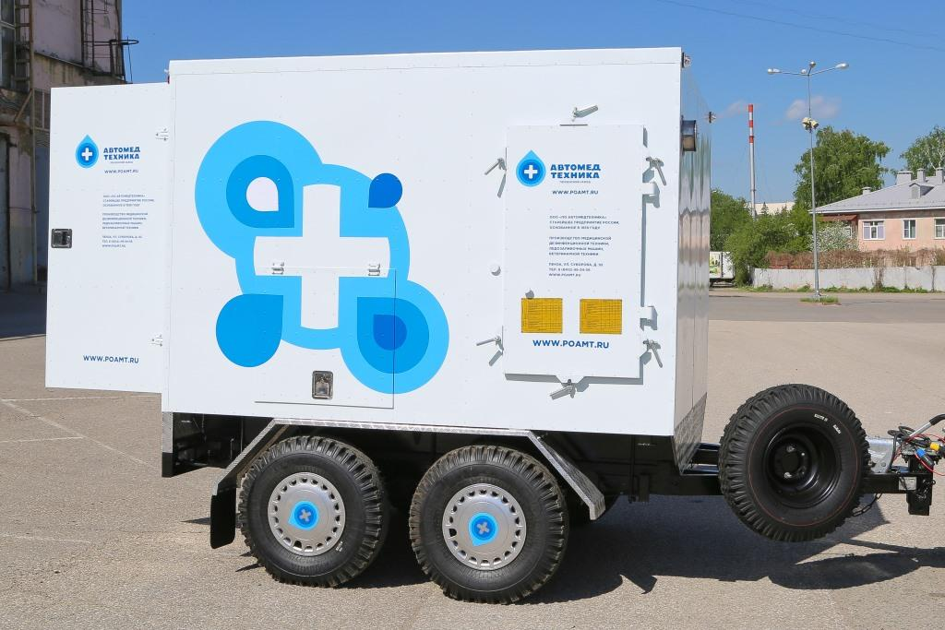
2. | Copy of manufacture certificate, if available

## | Other Mandatory Requirements | Compliance Remarks  The Bidders are required provide item-by-item commentary on the Technical Specifications demonstrating substantial responsiveness of the goods to those specifications (e.g. put “comply”), or a statement of deviations and exceptions to the provisions of the Technical Specifications
1. | All requested goods should be in new condition, never used before, packed in manufacture’s packages (Please confirm)
2. | Terms of delivery – DAP/DDP, OSCE Programme Office in Dushanbe, located at Ahmadi Donish 18A, Dushanbe, Tajikistan (please confirm).
3. | Delivery Schedule: 30 days after singing of contract. (Please confirm or specify in case of deviation)
4. | Acceptance of OSCE General Conditions of Contract (please confirm)
5. | Payment terms: 30 days net after provision of goods/services (Please confirm or specify in case of deviation)
6. | Mode of payment (bank transfer): [please confirm]
7. | Validity of offer 60 days minimum: (Please confirm or specify in case of deviation)
8. | Warranty period for goods: minimum 12 months.  (Please confirm or specify in case of deviation)
9. | Please provide photos for proposed equipment, if possible.

Company name:

Authorized representative’s name and stamp/signature:

Address:

Email:

Telephone:

