CLARIFICATION NOTE (Version-1)

Issue Date: 18.11.2024
Tender No.: ITB-SEC-706340-2024 for provision of Disaster Recovery Services

The OSCE would like to provide the following answers in regards to the received clarification questions by participating Bidders:

Question No. | Question | Answer
1 | Referring to the following requirement:  “The Bidder shall provide a server infrastructure to run virtual machines, which are currently based on VMWare vSphere 8.0.”  Are the VMWare licenses required? Would KVM be also applicable? | The licenses shall be offered as optional and it has to be VMWare vSphere. KVM is NOT an option.  This is the reason why there are two different rows in the Price Schedule (Annex I), as we need to know the costs for both options (with and without the VMWare licenses):  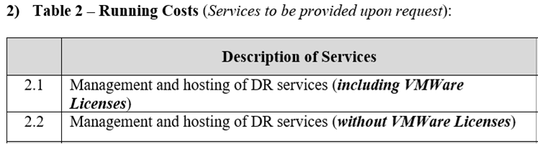
2 | Would OSCE also accept an alternative system (vendor) for the disaster recovery environment instead of the native replication mechanisms of HPE Primera storage? | An alternative solution cannot be accepted by the OSCE.

