CLARIFICATION SUMMARY

ITB SER 03 2025
Execution of Works at the MOI location Bezanijska kosa

Q1: LOT 1 requires one occupational health and safety person for the contracting authority. Is a contract with an agency that performs safety and health work for the Bidder acceptable as proof of employment? / LOT 1 zahteva angažovanje jednog lica za bezbednost i zdravlje na radu za izvodjaca. Da li je ugovor sa agencijom koja za Ponuđača obavlja poslove bezbednosti i zdravlja na radu prihvatljiv kao dokaz o zaposlenju?

A1: From the document ITB SER 03 2025 Annex C - Terms of reference, mandatory requirements and proofs for the Person responsible for safety and health at work are / Iz dokumenta ITB SER 03 2025 Aneks C – Projektni zadatak, obavezni uslovi i dokazi za lice odgovorno za bezbednost i zdravlje na radu su:
- A person who has passed the professional exam for practical competence in performing occupational safety and health tasks and who is designated by the employer in writing to carry out those tasks (Proof: Copy of Certificate for confirmation of the exam, copy of the Appointment Certificate for the Person responsible for safety and health at work or other decision document issued by the Bidder) / Lice sa položenim stručnim ispitom za praktičnu osposobljenost za obavljanje poslova bezbednosti i zdravlja na radu i koje je poslodavac pismenim putem odredio za obavljanje tih poslova (dokaz: kopija uverenja o položenom ispitu, kopija akta o imenovanju lica za bezbednost i zdravlje na radu ili druge odluke koju izdaje ponuđač)
- Employed or engaged by the Bidder (Contract of employment, service contract, or any other type of valid service agreement - Proof: Copy of the contract / service agreement) / Zaposlen ili angažovan od strane ponuđača (Ugovor o radu, ugovor o delu ili bilo koja druga vrsta važećeg ugovora o uslugama - Dokaz: Kopija ugovora o radu / delu)
- Experience in working for at least five years in a certain field of expertise, with a similar scope (Proof: CV with at least two references listed). / Iskustvo u radu najmanje pet godina u određenoj oblasti stručnosti, sa sličnim obimom (Dokaz: CV sa najmanje dve navedene reference).
As the second item allows for a service contract or agreement, a contract concluded with an agency providing occupational safety and health services to the Bidder may be accepted as proof of employment or engagement. / Kako je u drugoj stavci predviđena mogućnost dostavljanja ugovora o radu, ugovora o delu ili bilo kog drugog važećeg ugovora o uslugama, ugovor zaključen sa agencijom koja pruža usluge bezbednosti i zdravlja na radu za Ponuđača može se prihvatiti kao dokaz o zaposlenju ili angažovanju.

Q2: Is it permissible to hire the same civil engineer for multiple LOTs? / Da li je dozvoljeno angažovati istog građevinskog inženjera za više LOT-ova?

A2: In the document ITB SER 03 2025 Annex C - Terms of reference, after the paragraph defining mandatory requirements and proofs for LOT 1: Civil engineer, the responsible engineer for the execution of construction works who is to be the Site Manager simultaneously, it is noted: *If a Bidder submits bids for both LOT 1 and LOT 2, a single civil engineer who meets the mandatory requirements of this paragraph is sufficient for both LOTs.* / U dokumentu ITB SER 03 2025 Aneks C – Opis zadatka, nakon pasusa kojim se definišu obavezni uslovi i dokazi za LOT 1: Građevinski inženjer, odgovorni inženjer za izvođenje građevinskih radova koji istovremeno obavlja funkciju rukovodioca gradilišta, navedeno je: *Ako ponuđač podnosi ponude i za LOT1 i LOT2 dovoljan je jedan građevinski inženjer koji ispunjava obavezne zahteve iz ovog stava za oba LOT-a*
Since this is already noted, it is sufficient to engage a single civil engineer in case of a unified bid for LOT 1 and LOT 2. / S obzirom da je ovo već navedeno, dovoljno je angažovati jednog građevinskog inženjera u slučaju jedinstvene ponude za LOT 1 i LOT 2.

Q3: Does the 30-day period set out in the General Conditions also apply to the advance payment? / Da li i za avansnu uplatu važi rok od 30 dana iz opštih uslova.

A3: 30-day payment term also applies to advance payments. This period is required due to procedures with the tax authority regarding the granting of tax exemption, even though the actual payment is made within a much shorter timeframe. / Rok plaćanja od 30 dana važi i za avansne uplate. Ovaj rok je neophodan zbog procedure sa poreskom upravom radi ostvarivanja poreskog oslobođenja, iako se sama uplata obavlja u znatno kraćem roku.

Q4: Is there a construction permit for these works? If not, under which procedure are the works being carried out - as investment works or as routine maintenance? / Da li postoji građevinska dozvola za ove radove? Ukoliko ne postoji, na osnovu koje procedure se izvode radovi, kao investiciono ili tekuće održavanje?

A4: The documentation has been prepared for routine maintenance works, and obtaining a Construction Permit is not required / Dokumentacija je rađena za tekuće održavanje i nije potrebno ishodovanje Građevinske dozvole.

Q5: Is there a recommended sequence for the execution of works, considering that some sites may be simultaneously occupied by other space users? / Da li postoji preporučeni redosled izvođenja radova, imajući u vidu da neki poligoni mogu biti istovremeno zauzeti drugim aktivnostima korisnika prostora?

A5: The ‘Terms of Reference’ document states: Coordination among stakeholders regarding the planning of the detailed sequence and schedule of works is required prior to the commencement of works and throughout the entire construction process. The sequence of works depends on both the Contractor and the end user; therefore, coordination is necessary to ensure the execution of works alongside the user’s ongoing activities. Based on the agreement reached, which is the subject of the kick-off meeting prior to the commencement of works, the works may be carried out in phases, sequentially by sections (zones), etc. The complete works on the external fence facing the street shall be carried out first. / U dokumentu ‘Terms of reference’ je navedeno: Saradnja zainteresovanih strana oko planiranja detaljnog redosleda i rasporeda radova je neophodna pre početka radova i tokom celog procesa izgradnje. Redosled radova zavisi od Izvođača i korisnika, pa je potreban dogovor koji će omogućiti izvođenje radova i aktivnosti korisnika. Na osnovu dogovora, koji je predmet uvodnog sastanka pre početka radova, radovi se mogu izvoditi fazno, sekvencijalno po poligonima i sl. Prvo se izvode kompletni radovi na spoljnoj ogradi prema ulici.

Q6: Where are the electricity and water connections that the Contractor will be able to use located? / Gde se nalaze priključci za struju i vodu koje će Izvođač moći da koristi?

A6: Utility connections shall be subject to agreement with the end user, to be initiated at the kick-off meeting prior to the commencement of works. Cooperation with the end user is expected, including the possibility of using existing utility connections. It is assumed that the electrical supply for the construction site and execution of works can be arranged via the existing electrical outlet in the Main Distribution Board (MDB) located in the administrative building, which is designated by this technical documentation as the main supply line. The Contractor shall bear all costs related to the consumption of electricity and water for construction site purposes. / Priključci su predmet dogovora sa korisnikom, koji će biti pokrenut na uvodnom sastanku pre početka radova. Očekuje se saradnja sa korisnikom i mogućnost korišćenja postojećih priključaka. Pretpostavlja se da je elektro snabdevanje za potrebe gradilišta i izvođenja radova moguće rešiti preko postojećeg el. izvoda u postojećem GRO u objektu upravne zgrade, koji je ovom tehničkom dokumentacijom planiran za glavni napojni vod. Troškove potrošene el. energije i vode, za potrebe gradilišta, snosi Izvođač.

Q7: Is there a possibility to use some of the existing rooms as changing rooms for the workers, or as a dining area, or is the Contractor obliged to provide containers for accommodating personnel within the site complex? / Da li postoji mogućnost da se neke postojeće prostorije koriste kao prostorije za presvlačenje radnika, odnosno prostor za ručavanje ili je Izvođač u obavezi da obezbedi kontejnere za smeštaj ljudi u okviru kompleksa?

A7: This matter shall be addressed at the kick-off meeting prior to the commencement of works. The Contractor shall plan for the minimum necessary number of site containers required for the workforce. / Ovo pitanje biće predmet uvodnog sastanka pre početka radova. Planirati minimalan broj kontejnera za potrebe radnika

Q8: Is there a possibility to use the existing toilets, or is the Contractor obliged to provide chemical toilets within the site complex? / Da li postoji mogućnost da se koriste postojeće toaleti ili je Izvođač u obavezi da obezbedi hemijske toalete u okviru kompleksa?

A8: Existing sanitary facilities may not be used; the Contractor is required to provide chemical (portable) toilets. / Ne mogu se koristiti postojeći toaleti, Izvođač je u obavezi da obezbedi hemijske toalete

Q9: What exactly does the sentence "The contractor is responsible for verifying structural stability" refers to? / Na šta se konkretno odnosi rečenica "Izvođač je dužan da proveri statičku stabilnost"?

A9: If the Contractor procures and installs prefabricated products (metalwork, fences, etc.), they shall obtain the relevant documentation (technical datasheets and specifications) from the manufacturer. If the Contractor fabricates certain elements independently, they shall be required to perform the necessary calculations and provide the required supporting technical documentation and design justifications. / Ukoliko izvođač kupuje i ugrađuje gotov proizvod (bravarija, ograde...) potrebno je da pribavi odgovarajuću dokumentaciju (tehničke listove i specifikacije) od proizvođača. Ukoliko samostalno izrađuje određene elemente onda je neophodno da sam uradi proračune i dokaznice koje su potrebne.

Q10: Foundation structure for containers - The designed foundation beam-ring does not represent a conventional strip footing or slab and has a very small bearing area on the soil. In practice, it is difficult to construct a trench 30 cm wide, and even more difficult to compact a layer of crushed stone in such a trench, since it is not possible to use a compaction machine in such a narrow trench. Considering that concreting of the container slab is planned, we propose that, as is customary and sufficient for this type of structure (containers), a reinforced concrete slab with a thickness of 20 cm be cast on a previously compacted layer of crushed stone, with the necessary expansion joints. Accordingly, the unit price for item 3.2 should cover the concreting of a 20 cm thick slab. / Temeljna konstrukcija za kontejnere - Projektovana temeljna greda-prsten ne predstavlja klasičan trakasti temelj ili ploču i ima veoma malu površinu oslanjanja na tlo. U praksi, teško je izvesti rov širine 30cm, a još teže u takvom rovu izvršiti zbijanje sloja drobljenog kamena, s obzirom na to da nije moguće ubaciti mašinu za nabijanje u takvu širinu rova. S obzirom na to da je predviđeno betoniranje ploče za kontejnera predlažemo da se, kao što je uobičajeno i dovoljno za ovakav tip objekata (kontejneri), na prethodno nabijen sloj drobljenog kamena izvede AB ploča debljine d=20cm, sa neophodnim dilatacijama, odnosno da se jediničnom cenom za poziciju 3.2 obuhvati betoniranje ploče debljine 20cm.

A10: The foundations for the prefabricated containers are designed as a system of foundation counter-beams (tie beams). Given the limited geotechnical information available about the soil, this is one of the reasons for selecting this structural system. Counter-beams have higher moments of inertia and therefore greater stiffness, resulting in more uniform settlement and a reduced likelihood of cracking. Additionally, these beams are more heavily reinforced than strip foundations and distribute loads evenly, functioning as a grillage foundation system. In contrast, a foundation slab would be subject to significantly greater and more differential settlement compared to the grillage structure formed by the foundation beams. Another reason for this solution is material efficiency. Since the loads from the containers on the foundations are relatively low (less than 50 kPa/m²), the resulting soil stresses beneath the foundations are also low. Therefore, no special soil compaction is required beyond achieving the compaction modulus of the surrounding natural ground. Accordingly, vibro tampers (“jumping jacks”) with a working plate width of 20 to 30 cm may be used, as they are suitable for operation in narrow trenches. / Fundiranje montažnih kontejnera radi se na sistemu temeljnih kontragreda. Obzirom na to da se o samom terenu malo zna, upravo je to jedan od razloga za odabir ovog statičkog sistema. Kontragrede imaju veće momenate inercije, a samim tim i veću krutost, tako da su sleganja ravnomernija, a verovatnoća pojave pukotina manja. Takođe, grede su jače armirane od trakastih temelja i prenose opterećenje ravnomerno, kao roštiljni sistem. Upravo bi temeljna ploča imala znatno veća i neravnomernija sleganja od roštiljne konstrukcije koju formiraju temeljne grede. Drugi razlog je ušteda materijala. S obzirom da opterećenje od kontejnera na temelje nije veliko (manje od 50kPa/m2) pa samim tim ni naponi u tlu ispod temelja nisu veliki, nije propisano niti potrebno naročito zbijanje podloge već samo do modula zbijenosti okolnog prirodnog tla. S tim u vezi, moguće je upotrebiti vibro nabijače (žabe) čija se širina radne ploče kreće između 20 i 30cm a što im omogućava rad u uskim rovovima.

Q11: Foundation structure for fences VIII-1, VIII-2, and VIII-3 - Does the foundation structure lack a footing? A beam with a width of 30 cm and a height of 110 cm is planned. The small bearing area, the inability to properly compact the soil, and the long spans of the structure may result in uneven settlement and cracking. We propose that, instead of the tall beam, a conventional strip footing be constructed. / Temeljna konstrukcija za ograde VIII-1, VIII-2 i VIII-3 - Da li temeljnoj konstrukciji nedostaje stopa? Predviđena je greda širine 30cm, visine 110cm. Mala površina oslanjanja, nemogućnost da se izvrši dobro zbijanje tla, velike dužine prostiranja konstrukcije za posledicu mogu imati nejednako sleganje i pojavu pukotina. Predlažemo da se umosto visoke grede izvede klasičan trakasti temelj.

A11: The response is the same as for the previous question. The calculated soil bearing pressure is approximately 50 kN/m². One of the reasons for selecting the counter-beam system for the foundation structure is precisely to address settlement and cracking issues, as the greater stiffness of the counter-beams results in more uniform settlement and a reduced likelihood of cracking. Soil compaction shall be carried out using a vibro tamper (“jumping jack”). / Odgovor je isti kao na prethodno pitanje. Proračunati napon u tlu je oko 50kN/m2. Jedan od razloga za odabir sistema kontra-grede za temeljnu konstrukciju upravo jeste problem sleganja i pukotina s obzirom da su usled veće krutosti kontra-grede sleganja ravnomernija, a verovatnoća pojave pukotina manja. Zbijanje raditi "žabom".
Q12: Foundation structure for the stands and the dog run - As with the previous question, does the foundation structure lack a widened footing? Only a beam with a width of 30 cm is planned. The small bearing area, the inability to properly compact the soil, and the long spans may result in uneven settlement and cracking, which is particularly problematic for the position where the stands’ elements are to be mounted on the foundation. We propose that, instead of the tall beam, a conventional strip footing be constructed. / Temeljna konstrukcija za tribine i ispust za pse. Kao i za prethodno pitanje, da li temeljnoj konstrukciji nedostaje proširenje u vidu temeljne stope? Pedviđena je samo greda širine 30cm. Mala površina oslanjanja, nemogućnost da se izvrši dobro zbijanje tla, velike dužine prostiranja, može doći do nejednakog sleganja i pojava pukotina, što je posebno problematično za poziciju na čiju se temeljnu konstrukciju montiraju elementi tribina. Predlažemo da se umosto visoke grede izvede klasičan trakasti temelj.

A12: The response is the same as for the previous question. The calculated soil bearing pressure is < 50 kN/m². One of the reasons for selecting the counter-beam system for the foundation structure is to mitigate settlement and cracking, as the greater stiffness of the counter-beams ensures more uniform settlement and reduces the likelihood of cracking. Soil compaction shall be carried out using a vibro tamper (“jumping jack”). / Odgovor je isti kao na prethodno pitanje. Proračunati napon u tlu je < 50kN/m2. Jedan od razloga za odabir sistema kontra-grede za temeljnu konstrukciju upravo jeste problem sleganja i pukotina s obzirom da su usled veće krutosti kontra-grede sleganja ravnomernija, a verovatnoća pojave pukotina manja. Zbijanje raditi "žabom"

Q13: During a site visit, it was observed on location that the concrete foundation for the dog enclosures in the small training field, in the area of the future canopy, is in extremely poor condition and does not provide a reliable support for fixing of the new fence structure. Considering that in the technical description of the structure (Notebook 2.2 LOT2) the designer stated that the Contractor shall assess the condition of the concrete foundations and, if they are inadequate, shall cut the existing foundations and construct new ones, how should these works be included in the bid? / Obilaskom lokacije, na licu mesta utvrđeno je da je betonska temeljna konstrukcija za ispuste pasa na malom poligonu, u zoni buduće nadstrešnice, u izrazito lošem stanju, odnosno da ne predstavlja pouzdan oslonac za fiksiranje nove konstrukcije ograde. Imajući u vidu da je u tehničkom opisu konstrukcije (Sveska 2.2 LOT2) projektant napisao da Izvođač utvrđuje stanje betonskih temelja i ukoliko nisu adekvatni treba da izvrši prosecanje postojećih temelja i izvođenje novih, na koji način ove radove uvrstiti u ponudu?

A13: At the start of the works, a site inspection will be carried out by the civil engineer, the Contractor’s responsible representative, the site supervision team, and the OSCE Mission to Serbia's National Construction Officer. The condition of the foundations at the small polygon outlet will be assessed through a visual inspection and by determining the geometry via partial excavation of the foundations. If necessary, minimal investigative works may be agreed upon to determine the quality of the concrete and the presence and condition of the reinforcement. It should be noted that the function of the outlet foundations will not change; they were and will remain supports for the fence. The canopy has its own foundations. These works cannot be included in the bid; however, if their necessity is identified during the execution of the works, their implementation and payment will be allowed. Potential investigative works may be subject to an agreed request for execution of unforeseen works, while the construction of new foundations could be accommodated as surplus works under the relevant bill of quantities items. / Na početku radova biće izvršen obilazak lokacije od strane inženjera građevinske struke, odgovornog izvođača radova, stručnog nadzora i građevinske savetnice. Biće sagledano stanje temelja ispusta malog poligona kroz vizuelni pregled i određivanje geometrije iskopom dela temelja. Po potrebi biće dogovoreni minimalni istražni radovi za utvrđivanje kvaliteta betona i prisutvo i stanje armature. Napominje se da se funkcija temelja ispusta ne menja, oni su bili i ostaju oslonci ograde. Nadstrešnica ima sopstvene temelje. Ovi radovi se ne mogu uključiti u ponudu, ali ako se u toku radova utvrdi njihova neophodnost, biće omogućeno njihovo izvođenje i naplata. Potencijalni istražni radovi mogu biti predmet usaglašenog zahteva za izvođenje nepredviđenih radova, dok bi se za izvođenje novih temelja mogao primeniti višak radova odgovarajućih pozicija.

Q14: Has the relevant permit for the removal of existing trees on the subject plot already been obtained from the competent authority? Additionally, considering that the scope of tree removal is defined, will the exact locations of the trees be graphically indicated? / Da li je za seču postojećih stabala na predmetnoj parceli već pribavljena odgovarajuća dozvola od nadležnog organa? Takođe, imajući u vidu da je obim seče definisan, da li će se grafički označiti njihova tačna lokacija?

A14: Obtaining the permit from the competent authority for tree felling is the responsibility of the Logistics Department of the Ministry of Internal Affairs (MUP). The exact locations of the trees to be removed are indicated in the attachment “Existing Vegetation Status.” / Pribavljanje dozvole od nadležnog organa za seču stabala je u nadležnosti Odeljenja logistike MUPa. Tačna pozicija stabala koja se uklanjaju označena je u prilogu Postojeće stanje zelenila.

Q15: Please specify on which existing fence the metal strip is to be installed. Is it possible to install a PVC strip instead of the metal one? / Precizirati na kojoj postojećoj ogradi se postavlja limena traka? Da li je moguće postaviti PVC umesto limene?

A15: This concerns the fence on the southern boundary of the large polygon, adjacent to the neighboring parcel. The middle section needs to be enclosed to provide visual screening. The metal strip has been recommended by the fence manufacturer, as narrower strips are not available in their standard range. The middle section should be enclosed using the protruding verticals. Ideally, a narrower strip, as used on the rest of the fence, should be employed if available on the market and if its attachment is feasible. Alternatively, the strip could be cut lengthwise to produce narrower strips—this should be confirmed with the manufacturer. The upper and lower zones of the panels must remain open to allow for wind passage. / U pitanju je ograda na južnoj granici parcele velikog poligona, prema susednoj parceli. Srednje polje je potrebno zatvoriti radi zaštite od pogleda. Limenu traku je preporučio proizvođač ovakve ograde jer u asortimanu nema uske trake. Potrebno je zatvoriti srednje polje sa ispupčenim vertikalama. Bilo bi najbolje upotrebiti užu traku kao što je na ostatku ograde ukoliko je ima na tržištu i ukoliko je moguće njeno pričvršćivanje, ili bi traka mogla da se seče uzduž kako bi se dobile uže trake...proveriti sa proizvođačem. Donja i gornja zona panela moraju ostati otvorene zbog vetra

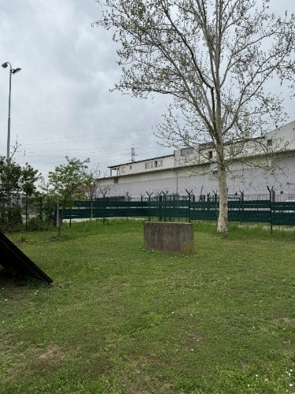 |  | 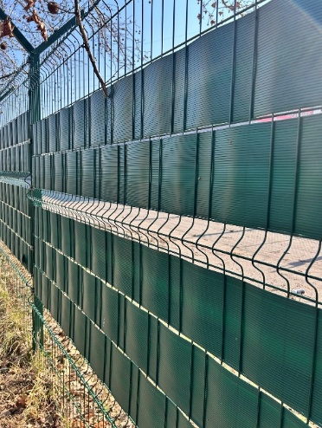

Q16: Do the items under Earthworks 2.6 (small training field) and 2.4 (large training field) include the placement of topsoil in a 20 cm thick layer, including the supply/procurement of new topsoil? / Da li pozicije u sklopu zemljanih radova 2.6. (mali poligon) i 2.4. (veliki pologon) podrazumevaju nasipanje humusa u sloju d=20cm uključujući nabavku novog humusa?

A16: Yes, it involves the procurement, delivery, and placement (spreading) of new topsoil. / Da, u pitanju je nabavka, dovoz i nasipanje novog humusa

Q17: Item IV. Installation works (within Plumbing and Drainage Works), item 7 – Supply, transport, and installation of drinking fountains as selected by the Employer: the Employer is required to specify the exact type / model of the drinking fountain. / Pozicija IV. Montažerski radovi (u sklopu ViK radova) 7. Nabavka transport i ugradnja česmi po izboru korisnika, potrebno je da Investitor definiše tačan tip česme

A17: A simple courtyard fountain (yard tap) is planned, which may be modeled after the two examples shown below. The tap shall be equipped with a hose connection / Projektovana je jednostavna dvorišna česma, može biti po ugledu na dve prikazane u nastavku, slavina ima priključak za crevo

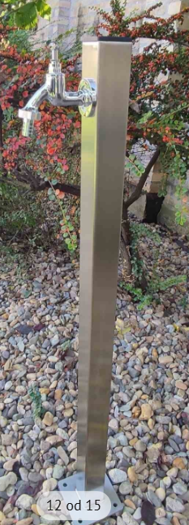 | 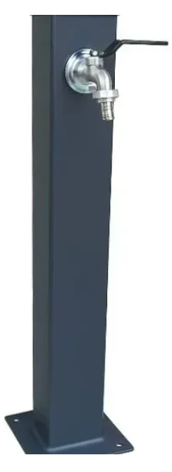 | 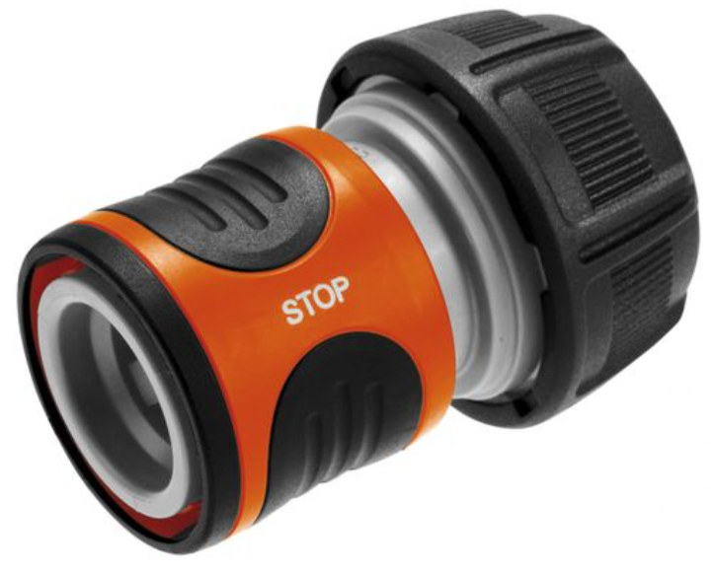  hose connector / priključak za crevo

Q18: The Contract template defines a Performance Security; however, the Advance Payment Guarantee and the Defects Liability Period Guarantee are not defined and need to be specified / U modelu ugovora je definisana bankarska garancija za dobro izvršenje posla, nije definisana garancija za povraćaj avansa i za garantni period, potrebno je definisati preostale garancije

A18: An advance payment guarantee and a warranty period guarantee are not required under this tender / Garancija za povracaj avansa, kao i garancija za garantni period nisu predvidjene po ovom tenderu

Q19: It is necessary to specify the payment period in the draft Contract / Potrebno je precizirati rok plaćanja u modelu ugovora

A19: 30-day payment term is defined within Annex B - OSCE General Conditions of Contract. This period is required due to procedures with the tax authority regarding the granting of tax exemption, even though the actual payment is made within a much shorter timeframe. / Rok plaćanja od 30 dana je definisan u dokumentu Aneks B – Opsti uslovi ugovora OEBS-a. Ovaj rok je neophodan zbog procedure sa poreskom upravom radi ostvarivanja poreskog oslobođenja, iako se sama uplata obavlja u znatno kraćem roku

Q20: In Annex C – Terms of Reference, page 7, section 5.3 Expert Qualifications, the following is stated: / U Annex C PROJEKTNI ZADATAK na strani 7, tačka 5.3. Kvalifikacije stručnjaka navodi se sledeće:
LOT 1: Civil engineer, the responsible engineer for the execution of construction works
who is to be the Site Manager simultaneously / Građevinski inženjer, odgovorni izvođač građevinskih radova koji rukovodi izvođenjem Radova

Mandatory requirements: / Obavezni zahtevi:
  - Civil engineer, the responsible engineer for the execution of construction works with a university degree, certified for the execution of works as prescribed by the related legislation - Personal License 410 or 411 or GI 04-01.1 (Proof: Copy of License) / Građevinski inženjer, odgovorni izvođač građevinskih radova koji rukovodi izvođenjem radova sa univerzitetskom diplomom, ovlašćen za izvođenje radova propisanih odgovarajućim zakonom – Lična licenca 410 ili 411 ili GI 04-01.1 (Dokaz: Kopija licence)
  - Employed by the Bidder (Proof: a copy of the employment contract) / Zaposlen kod ponuđača (dokaz: kopija ugovora o radu)
  - Experience as a manager of works in at least two (2) projects of exterior development, landscape architecture and horticultural works in parks, city gardens, open recreational spaces, promenades, picnic areas, botanical and zoo gardens, open spaces of residential blocks, hotels, schools, hospitals, children's institutions, or projects for buildings which included open spaces of residential blocks, hotels, schools, hospitals, children's institutions, within the last five years (Proof: CV with at least two references listed) / Iskustvo kao rukovodilac izvođenja radova na najmanje dva (2) projekta pejzažno-arhitektonskog uređenja prostora i hortikulture za parkove, gradske vrtove, otvorene rekreativne prostore, šetališta, izletišta, botaničke i zoo vrtove, otvorene prostore stambenih blokova, hotela, škola, bolnica, dečjih ustanova, ili projektima za zgrade koji su uključivali otvorene prostore stambenih blokova, hotela, škola, bolnica, dečjih ustanova u poslednjih pet godina (Dokaz: CV sa najmanje dve navedene reference)
  - Experience as a responsible engineer for the execution of construction works in at least two (2) projects of exterior development, landscape architecture and horticultural works in parks, city gardens, open recreational spaces, promenades, picnic areas, botanical and zoo gardens, open spaces of residential blocks, hotels, schools, hospitals, children's institutions, or projects for buildings which included open spaces of residential blocks, hotels, schools, hospitals, children's institutions, within the last five years (Proof: CV with at least two references listed) / Iskustvo na poslovima odgovornog izvođača građevinskih radova, za izvođenje radova na najmanje dva (2) projekta pejzažno-arhitektonskog uređenja prostora i hortikulture za parkove, gradske vrtove, otvorene rekreativne prostore, šetališta, izletišta, botaničke i zoo vrtove, otvorene prostore stambenih blokova, hotela, škola, bolnica, dečjih ustanova, ili projektima za zgrade koji su uključivali otvorene prostore stambenih blokova, hotela, škola, bolnica, dečjih ustanova, u poslednjih pet godina (Dokaz: CV sa najmanje dve navedene reference)
Considering that License 410 is primarily related to the execution of building construction works (high-rise construction), please clarify whether the required experience may include experience in managing construction works within civil engineering projects. / S obzirom na to da je licenca 410 primarno vezana za izvođenje građevinskih radova na objektima visokogradnje, molimo za pojašnjenje da li je prihvatljivo da traženo iskustvo obuhvata rukovođenje radovima u okviru građevinskih projekata.
Furthermore, please confirm whether, in addition to Licenses 410 or 411 or GI 04-01.1, it would be acceptable for the proposed expert to hold License 412, taking into account the nature of the Works and the required experience. / Takođe, molimo za potvrdu da li je, pored licenci 410 ili 411 ili GI 04-01.1, prihvatljivo da predloženi stručnjak poseduje licencu 412, imajući u vidu prirodu radova i zahtevano iskustvo.

A20: The required references for site management already include external landscaping works as well as works on “building projects,” which constitutes a broad scope of references most similar to the planned works. The mandatory requirements specified in the Terms of Reference (Annex C – Project Brief) remain in force. / Navedene reference za rukovođenje već obuhvataju radove na spoljnom uređenju, kao i radove na “projektima za zgrade”, što čini široki opseg referenci najsličnijih planiranim radovima. Obavezni zahtevi specificirani u dokumentu Terms of Reference (Annex C Projektni zadatak) ostaju na snazi.
The proposal to include License 412 in the list of licenses for the responsible contractor managing the works is not accepted. The mandatory requirements specified in the Terms of Reference (Annex C – Project Brief) remain in force. / Ne prihvata se predlog da se licenca 412 uključi u listu licenci odgovornog izvođača koji rukovodi radovima. Obavezni zahtevi specificirani u dokumentu Terms of Reference (Annex C Projektni zadatak) ostaju na snazi.

Q21: Please provide clarification regarding the role and engagement modality of the Occupational Health and Safety (OHS) Officer on the Project. Is the OHS Officer required to be continuously engaged on the Project for the entire duration of the Works, i.e. permanently present on site, or would it be acceptable for the OHS Officer to conduct periodic site visits, in accordance with the applicable regulations and the needs of the Project? / Molimo za pojašnjenje u vezi sa ulogom i načinom angažovanja lica za bezbednost i zdravlje na radu (BZR) na projektu. Da li se zahteva da lice za BZR bude stalno angažovano na projektu tokom celokupnog perioda izvođenja radova, odnosno da bude prisutno na gradilištu u kontinuitetu, ili je prihvatljivo da vrši povremene obilaske gradilišta, u skladu sa važećim propisima i potrebama projekta?

A21: The scope of engagement of the person responsible for occupational health and safety depends on a number of factors, including the scope and nature of the works, the level of risk associated with the execution of the works, the company’s overall safety approach, coordination between technical staff and workers regarding safety responsibilities, as well as worker training and their awareness of the obligation to comply with and implement the prescribed safety measures. / Obim angažovanja lica odgovornog za bezbednost i zdravlje na radu zavisi od brojnih faktora, uključujući obim i prirodu radova, nivo rizika pri izvođenju radova, sveukupni pristup kompanije bezbednosti, koordinaciju između tehničkog osoblja i radnika po pitanjima odgovornosti u vezi sa bezbednošću, kao i obuku radnika i njihovu svest o obavezi da se pridržavaju i sprovode naložene mere bezbednosti.
The person responsible for occupational health and safety shall cooperate with the Occupational Health and Safety Coordinator during the construction phase and shall ensure that the Contractor’s workers comply with and implement the prescribed safety measures / Lice odgovorno za bezbednost i zdravlje na radu sarađivaće sa Koordinatorom za bezbednost i zdravlje na radu u fazi izvođenja radova i vodiće računa da se radnici Izvođača radova pridržavaju i sprovode naložene mere bezbednosti

