 | SCB solution  (Customization #0159)  Overview

1. Introduction

1.1. Purpose
This document will provide an overview of the OSCE SCB (Supplier Custom and Bank) Master Data Approval solution.

1.2. Further material
Further material can be found in the customization folder on DocIn - https://docin.osce.org/docin/llisapi.dll?func=ll&objId=21001771&objAction=browse&viewType=1

2. Process

2.1. Process description
Registering of customers, suppliers and or banks are done centrally. This entails that users in Missions/Institutions only register and submit items for approval. Based on the submission of the information the items are validated for data quality and consistency before they are approved for usage.

By submitting a new item or submitting a change of item information, a notification is sent to the mission approver to inform about a new entry for validation. This mission approver approves or rejects this change. If approving a central approver gets notified about the changes. Upon approval, a notification is sent back to the user that requested a new/changed customer, supplier, bank confirming the registration of the information.

Extensions reuse customer, supplier and bank registration forms and functions. Customisations are built for submitted items into the real customer register, and to use notifications for communication. The figure below shows the workflow for suppliers, but this also applies for customers and banks.

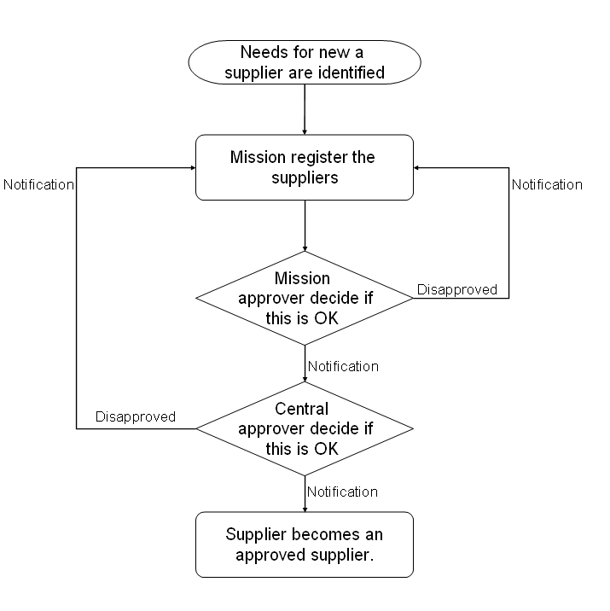

3. Technical design

3.1. Program flow

In the sketch above there is indicated how the data are displayed in the different responsibilities. There has to be established three types of responsibilities, mission responsibilities, mission approval responsibilities and central approval responsibilities.

Mission suggestion responsibilities:
Those are used in the missions and institutions. Here an item creation or change suggestion is submitted. Users are allowed to search and look at data in the system tables, but can not create new or update existing customers in the system tables. The changes the users do are stored in custom tables. These types of responsibilities are linked to a custom data group (XX_DC schema). The responsibility starts the workflow ‘Master Data Approval’ by the special menu in the tool bar. For Suppliers and Banks the Approval History is provided in a form which is available by the special menu in the tool bar.

Mission approval responsibilities:
These responsibilities have mainly the same privileges as the suggestion responsibilities. The difference is that these responsibilities provide the ability to mark the item (record) as approved which is done by approving the record in the approval notification which is sent out by the workflow ‘Master Data Approval’. For Suppliers and Banks the Approval History is provided in a form which is available by the special menu in the tool bar.

Central approval responsibilities:
Users in the central administration are going to use the approval responsibilities. These users are able to make changes to data in the system tables, and as well create new ones. These users are notified when a suggestion is submitted and the mission approver has approved it. These types of responsibilities are linked to the standard data group.

3.2 Objects on XX_DC schema

Follwing list provides an overview of the objects and functionality in the XX_DC schema:

Object | Object type | Refers to object | Context  Supplier  Customer  Bank | Description
HZ_PARTIES_I1 | INDEX
OSCE_AUDIT_PKG | PACKAGE |  | SCB | Building audit trail (inserts into xx_dc.osce_audit_tbl)
XXDC_CREATE_TABLES | PACKAGE |  | SCB | Package to create views in XX_DC schema for  * creates mirrored tables  HZ_CUST_ACCOUNTS  HZ_CUST_ACCOUNT_ROLES  HZ_PARTY_SITES  HZ_CUST_ACCT_SITES_ALL  HZ_CUST_PROFILE_AMTS  HZ_CONTACT_POINTS  HZ_CUST_SITE_USES_ALL  HZ_CUSTOMER_PROFILES  HZ_PARTIES  HZ_PARTY_SITE_USES  AP_BANK_ACCOUNTS_ALL  AP_BANK_ACCOUNT_USES_ALL  AP_BANK_BRANCHES  PO_VENDORS  PO_VENDOR_CONTACTS  PO_VENDOR_SITES_ALL  * create triggers with send_xxdc_trg_ prefix for mirrored tables  * create triggers with execute_xxdc_trg_ prefix for mirrored tables
XXDC_CREATE_VIEWS | PACKAGE |  | SCB | Package to create views and all dependant views in XX_DC schema for  AP_BANK_ACCOUNTS  AP_BANK_ACCOUNT_USES_V  AP_BANK_BRANCHES_V  AP_VENDORS_V  AP_VENDOR_SITES_V  AR_ADDRESSES_V  AR_CONTACTS_V  AR_CUSTOMERS_V  AR_CUSTOMER_BANK_ACCOUNTS_V  AR_CUSTOMER_PROFILES_V  AR_CUSTOMER_RELATIONSHIPS_V  AR_CUST_RECEIPT_METHODS_V  AR_PHONES_V
XXDC_MOVE_TO_XXDC | PACKAGE |  | SCB
OSCE_AUDIT_S | SEQUENCE |  | SCB | Sequence to build audit trails (OSCE_AUDIT_TBL)
XXDC_WF_S | SEQUENCE |  | SCB | Sequence for OSCE Master Data Approval Workflow
AP_BANK_ACCOUNTS_ALL | TABLE |  | B | Custom table - Mirrored table from standard schema
AP_BANK_ACCOUNT_USES_ALL | TABLE |  | B | Custom table - Mirrored table from standard schema
AP_BANK_BRANCHES | TABLE |  | B | Custom table - Mirrored table from standard schema
HZ_CONTACT_POINTS | TABLE |  | C | Custom table - Mirrored table from standard schema
HZ_CUSTOMER_PROFILES | TABLE |  | C | Custom table - Mirrored table from standard schema
HZ_CUST_ACCOUNTS | TABLE |  | C | Custom table - Mirrored table from standard schema
HZ_CUST_ACCOUNT_ROLES | TABLE |  | C | Custom table - Mirrored table from standard schema
HZ_CUST_ACCT_SITES_ALL | TABLE |  | C | Custom table - Mirrored table from standard schema
HZ_CUST_PROFILE_AMTS | TABLE |  | C | Custom table - Mirrored table from standard schema
HZ_CUST_SITE_USES_ALL | TABLE |  | C | Custom table - Mirrored table from standard schema
HZ_PARTIES | TABLE |  | C | Custom table - Mirrored table from standard schema
HZ_PARTIES_BKP | TABLE |  | C | Custom table - Mirrored table from standard schema
HZ_PARTY_SITES | TABLE |  | C | Custom table - Mirrored table from standard schema
HZ_PARTY_SITE_USES | TABLE |  | C | Custom table - Mirrored table from standard schema
OSCE_AUDIT_TBL | TABLE |  | SCB | Custom table - Mirrored table from standard schema
OSCE_XXDC_APPROVAL_HISTORY | TABLE |  | SCB | Custom table - Mirrored table from standard schema
PO_VENDORS | TABLE |  | S | Custom table - Mirrored table from standard schema
PO_VENDOR_CONTACTS | TABLE |  | S | Custom table - Mirrored table from standard schema
PO_VENDOR_SITES_ALL | TABLE |  | S | Custom table - Mirrored table from standard schema
OSCE_XXDC_BANK_ACCTS_BIU_TRG | BEFORE EACH ROW INSERT OR UPDATE TRIGGER | XX_DC.AP_BANK_ACCOUNTS_ALL | B | Inserts changes in OSCE_AUDIT_TBL table to provide change information in workflow notification (osce_audit_pkg.check_value)
OSCE_XXDC_BANK_ACC_USE_BIU_TRG | BEFORE EACH ROW INSERT OR UPDATE TRIGGER | XX_DC.AP_BANK_ACCOUNT_USES_ALL | B | Inserts changes in OSCE_AUDIT_TBL table to provide change information in workflow notification (osce_audit_pkg.check_value)
OSCE_XXDC_BANK_BRANCHS_BIU_TRG | BEFORE EACH ROW INSERT OR UPDATE TRIGGER | XX_DC.AP_BANK_BRANCHES | B | Inserts changes in OSCE_AUDIT_TBL table to provide change information in workflow notification (osce_audit_pkg.check_value)
OSCE_XXDC_VENDORS_BIU_TRG | BEFORE EACH ROW INSERT OR UPDATE TRIGGER | XX_DC.PO_VENDORS | S | Inserts changes in OSCE_AUDIT_TBL table to provide change information in workflow notification (osce_audit_pkg.check_value)
OSCE_XXDC_VENDOR_CONTA_BIU_TRG | BEFORE EACH ROW INSERT OR UPDATE TRIGGER | XX_DC.PO_VENDOR_CONTACTS | S | Inserts changes in OSCE_AUDIT_TBL table to provide change information in workflow notification (osce_audit_pkg.check_value)
OSCE_XXDC_VENDOR_SITES_BIU_TRG | BEFORE EACH ROW INSERT OR UPDATE TRIGGER | XX_DC.PO_VENDOR_SITES_ALL | S | Inserts changes in OSCE_AUDIT_TBL table to provide change information in workflow notification (osce_audit_pkg.check_value)
AP_BANK_ACCOUNTS | VIEW |  |  | Custom view - Mirrored view from standard schema
AP_BANK_ACCOUNT_USES | VIEW |  |  | Custom view - Mirrored view from standard schema
AP_BANK_ACCOUNT_USES_V | VIEW |  |  | Custom view - Mirrored view from standard schema
AP_BANK_BRANCHES_V | VIEW |  |  | Custom view - Mirrored view from standard schema
AP_DISTRIBUTION_SETS | VIEW |  |  | Custom view - Mirrored view from standard schema
AP_LOOKUP_CODES | VIEW |  |  | Custom view - Mirrored view from standard schema
AP_TERMS_VL | VIEW |  |  | Custom view - Mirrored view from standard schema
AP_VENDORS_V | VIEW |  |  | Custom view - Mirrored view from standard schema
AP_VENDOR_SITES_V | VIEW |  |  | Custom view - Mirrored view from standard schema
AR_ADDRESSES_V | VIEW |  |  | Custom view - Mirrored view from standard schema
AR_CONTACTS_V | VIEW |  |  | Custom view - Mirrored view from standard schema
AR_CUSTOMERS_V | VIEW |  |  | Custom view - Mirrored view from standard schema
AR_CUSTOMER_BANK_ACCOUNTS_V | VIEW |  |  | Custom view - Mirrored view from standard schema
AR_CUSTOMER_PROFILES_V | VIEW |  |  | Custom view - Mirrored view from standard schema
AR_CUSTOMER_RELATIONSHIPS_V | VIEW |  |  | Custom view - Mirrored view from standard schema
AR_CUST_RECEIPT_METHODS_V | VIEW |  |  | Custom view - Mirrored view from standard schema
AR_LOOKUPS | VIEW |  |  | Custom view - Mirrored view from standard schema
AR_PHONES_V | VIEW |  |  | Custom view - Mirrored view from standard schema
FND_LANGUAGES_VL | VIEW |  |  | Custom view - Mirrored view from standard schema
FND_TERRITORIES_VL | VIEW |  |  | Custom view - Mirrored view from standard schema
HZ_CONTACT_RESTRICTIONS | VIEW |  |  | Custom view - Mirrored view from standard schema
HZ_CUSTOMER_PARTY_FIND_V | VIEW |  |  | Custom view - Mirrored view from standard schema
HZ_CUST_ACCT_RELATE | VIEW |  |  | Custom view - Mirrored view from standard schema
HZ_CUST_ACCT_SITES | VIEW |  |  | Custom view - Mirrored view from standard schema
JTF_RS_RESOURCE_EXTNS_VL | VIEW |  |  | Custom view - Mirrored view from standard schema
OE_LOOKUPS_115 | VIEW |  |  | Custom view - Mirrored view from standard schema
OE_ORDER_TYPES_115 | VIEW |  |  | Custom view - Mirrored view from standard schema
OE_PRICE_LISTS_115_VL | VIEW |  |  | Custom view - Mirrored view from standard schema
OE_PRICE_LISTS_VL | VIEW |  |  | Custom view - Mirrored view from standard schema
OE_TRANSACTION_TYPES_VL | VIEW |  |  | Custom view - Mirrored view from standard schema
ORG_FREIGHT_VL | VIEW |  |  | Custom view - Mirrored view from standard schema
PO_LOOKUP_CODES | VIEW |  |  | Custom view - Mirrored view from standard schema
PO_VENDOR_SITES | VIEW |  |  | Custom view - Mirrored view from standard schema
QP_LIST_HEADERS_VL | VIEW |  |  | Custom view - Mirrored view from standard schema
QP_PRICE_LISTS_V | VIEW |  |  | Custom view - Mirrored view from standard schema
RA_SALESREPS | VIEW |  |  | Custom view - Mirrored view from standard schema
RA_TERMS_VL | VIEW |  |  | Custom view - Mirrored view from standard schema
APXSUMBA | Forms Personalization |  |  | Forms Personalization builds  * Tools-menu  * calls functions on tools menu item  * locks fields when workflow is in progress  Is just available if form is executed under XX_DC schema
APXVDMVD (Supplier) | DFF |  |  | 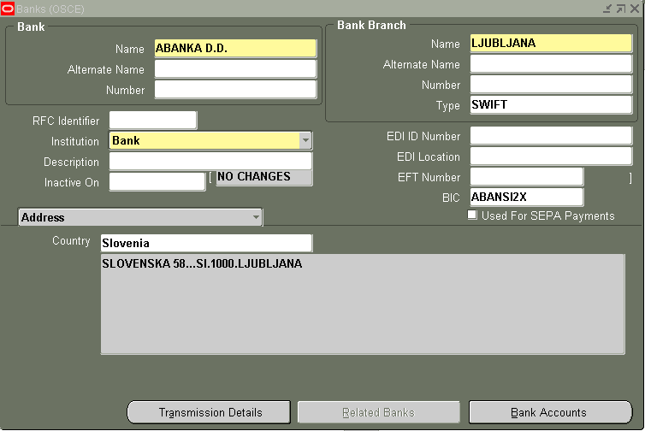
APXVDMVD (Supplier) | Forms Personalization |  |  | Forms Personalization builds  * Tools-menu  * calls functions on tools menu item  * locks fields when workflow is in progress  Is just available if form is executed under XX_DC schema
APXVDMVD (Supplier) | DFF |  |  | 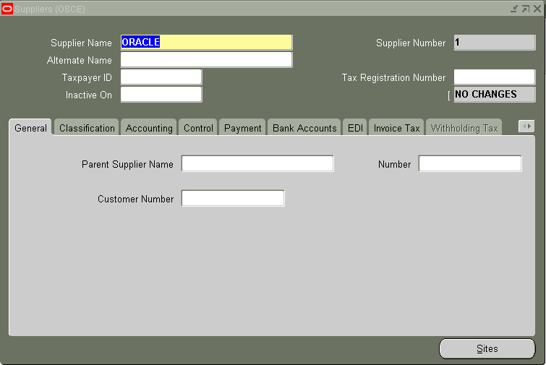
XXDCAHV | Form |  |  | Form which shows approval history of supplier  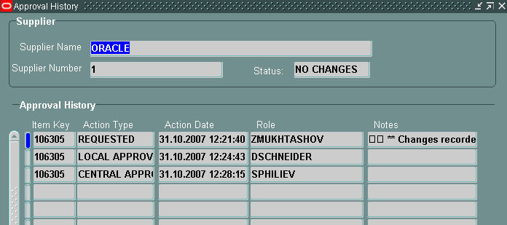

3.3 Objects of SCB solution on APPS schema

Follwing list provides an overview of the objects and functionality in the APPS schema which are related to the SCB solution:

Object | Object type | Refers to object | Context  Supplier  Customer  Bank | Description
XXDC_BANK | PACKAGE |  | B | Provides function to transfer bank data from XX_DC to APPS schema and is triggerd by the OSCE Master Approval workflow
XXDC_CUSTOMER | PACKAGE |  | C | Provides function to transfer customer data from XX_DC to APPS schema and is triggerd by the OSCE Master Approval workflow
XXDC_SUPPLIER | PACKAGE |  | S | Provides function to transfer supplier data from XX_DC to APPS schema and is triggerd by the OSCE Master Approval workflow
XX_DC_WORKFLOW | PACKAGE |  | SCB | Package provides function for workflow oSCE Master Data Approval  * Start workflow depending on object type (Supplier/Customer/Bank)  * Approver (based on Position Structure 'OSCE_MASTER_DATA_APPROVAL')  * Approve object  * Reject object  * Notificaton content
OSCE_XXDC_PKG | PACKAGE |  | SCB | Provides function to  * generate audit trail text for notification  * identify structure differences between XX_DC schema and APPS schema  * gerenerate script to change table structure between XX_DC schema and APPS schema  * create approval history- called from :  1. Start the Workflow : APPS.XXDC_WORKFLOW.start_process  2a. Local Approval : APPS.XXDC_WORKFLOW.ApproveObject  2b. Local Rejected : APPS.XXDC_WORKFLOW.RejectObject  3a. Central Approved: APPS.XXDC_WORKFLOW.cntr_appr_object  3b. Central Rejected : APPS.XXDC_WORKFLOW.RejectObject
EXECUTE_XXDC_TRG_50214 | AFTER STATEMENT INSERT OR UPDATE | APPS.AP_BANK_ACCOUNTS_ALL | B | Moves data from APPS into XX_DC schema (xx_dc.xxdc_move_to_xxdc.execute_move)
EXECUTE_XXDC_TRG_50215 | AFTER STATEMENT INSERT OR UPDATE | APPS.AP_BANK_BRANCHES | B | Moves data from APPS into XX_DC schema  (xx_dc.xxdc_move_to_xxdc.execute_move)
EXECUTE_XXDC_TRG_50708 | AFTER STATEMENT INSERT OR UPDATE | APPS.PO_VENDORS | S | Moves data from APPS into XX_DC schema  (xx_dc.xxdc_move_to_xxdc.execute_move)
EXECUTE_XXDC_TRG_50709 | AFTER STATEMENT INSERT OR UPDATE | APPS.PO_VENDOR_CONTACTS | S | Moves data from APPS into XX_DC schema (xx_dc.xxdc_move_to_xxdc.execute_move)
EXECUTE_XXDC_TRG_50712 | AFTER STATEMENT INSERT OR UPDATE | APPS.PO_VENDOR_SITES_ALL | S | Moves data from APPS into XX_DC schema (xx_dc.xxdc_move_to_xxdc.execute_move)
EXECUTE_XXDC_TRG_53152 | AFTER STATEMENT INSERT OR UPDATE | APPS.AP_BANK_ACCOUNT_USES_ALL | B | Moves data from APPS into XX_DC schema (xx_dc.xxdc_move_to_xxdc.execute_move)
EXECUTE_XXDC_TRG_69366 | AFTER STATEMENT INSERT OR UPDATE | APPS.HZ_CUST_ACCOUNT_ROLES | C | Moves data from APPS into XX_DC schema (xx_dc.xxdc_move_to_xxdc.execute_move)
EXECUTE_XXDC_TRG_69383 | AFTER STATEMENT INSERT OR UPDATE | APPS.HZ_PARTY_SITES | C | Moves data from APPS into XX_DC schema (xx_dc.xxdc_move_to_xxdc.execute_move)
EXECUTE_XXDC_TRG_70543 | AFTER STATEMENT INSERT OR UPDATE | APPSHZ_CUST_ACCT_SITES_ALL | C | Moves data from APPS into XX_DC schema (xx_dc.xxdc_move_to_xxdc.execute_move)
EXECUTE_XXDC_TRG_70631 | AFTER STATEMENT INSERT OR UPDATE | APPS.HZ_CUST_PROFILE_AMTS | C | Moves data from APPS into XX_DC schema (xx_dc.xxdc_move_to_xxdc.execute_move)
EXECUTE_XXDC_TRG_78669 | AFTER STATEMENT INSERT OR UPDATE | APPS.HZ_CONTACT_POINTS | C | Moves data from APPS into XX_DC schema (xx_dc.xxdc_move_to_xxdc.execute_move)
EXECUTE_XXDC_TRG_78672 | AFTER STATEMENT INSERT OR UPDATE | APPS.HZ_CUST_ACCOUNTS | C | Moves data from APPS into XX_DC schema (xx_dc.xxdc_move_to_xxdc.execute_move)
EXECUTE_XXDC_TRG_78673 | AFTER STATEMENT INSERT OR UPDATE | APPS.HZ_CUST_SITE_USES_ALL | C | Moves data from APPS into XX_DC schema (xx_dc.xxdc_move_to_xxdc.execute_move)
EXECUTE_XXDC_TRG_78675 | AFTER STATEMENT INSERT OR UPDATE | APPS.HZ_CUSTOMER_PROFILES | C | Moves data from APPS into XX_DC schema (xx_dc.xxdc_move_to_xxdc.execute_move)
EXECUTE_XXDC_TRG_78682 | AFTER STATEMENT INSERT OR UPDATE | APPS.HZ_PARTIES | C | Moves data from APPS into XX_DC schema (xx_dc.xxdc_move_to_xxdc.execute_move)
EXECUTE_XXDC_TRG_78683 | AFTER STATEMENT INSERT OR UPDATE | APPS.HZ_PARTY_SITE_USES | C | Moves data from APPS into XX_DC schema (xx_dc.xxdc_move_to_xxdc.execute_move)
SEND_XXDC_TRG_50214 | BEFORE EACH ROW INSERT OR UPDATE TRIGGER | APPS.AP_BANK_ACCOUNTS_ALL | B | adds a record to the trigger_table enter in APPS schema (xx_dc.xxdc_move_to_xxdc.move_to_xxdc)
SEND_XXDC_TRG_50215 | BEFORE EACH ROW INSERT OR UPDATE TRIGGER | APPS.AP_BANK_BRANCHES | B | adds a record to the trigger_table enter in APPS schema (xx_dc.xxdc_move_to_xxdc.move_to_xxdc)
SEND_XXDC_TRG_50708 | BEFORE EACH ROW INSERT OR UPDATE TRIGGER | APPS.PO_VENDORS | S | adds a record to the trigger_table enter in APPS schema (xx_dc.xxdc_move_to_xxdc.move_to_xxdc)
SEND_XXDC_TRG_50709 | BEFORE EACH ROW INSERT OR UPDATE TRIGGER | APPS.PO_VENDOR_CONTACTS | S | adds a record to the trigger_table enter in APPS schema (xx_dc.xxdc_move_to_xxdc.move_to_xxdc)
SEND_XXDC_TRG_50712 | BEFORE EACH ROW INSERT OR UPDATE TRIGGER | APPS.PO_VENDOR_SITES_ALL | S | adds a record to the trigger_table enter in APPS schema (xx_dc.xxdc_move_to_xxdc.move_to_xxdc)
SEND_XXDC_TRG_53152 | BEFORE EACH ROW INSERT OR UPDATE TRIGGER | APPS.AP_BANK_ACCOUNT_USES_ALL | B | adds a record to the trigger_table enter in APPS schema (xx_dc.xxdc_move_to_xxdc.move_to_xxdc)
SEND_XXDC_TRG_69366 | BEFORE EACH ROW INSERT OR UPDATE TRIGGER | APPS.HZ_CUST_ACCOUNT_ROLES | C | adds a record to the trigger_table enter in APPS schema (xx_dc.xxdc_move_to_xxdc.move_to_xxdc)
SEND_XXDC_TRG_69383 | BEFORE EACH ROW INSERT OR UPDATE TRIGGER | APPS.HZ_PARTY_SITES | C | adds a record to the trigger_table enter in APPS schema (xx_dc.xxdc_move_to_xxdc.move_to_xxdc)
SEND_XXDC_TRG_70543 | BEFORE EACH ROW INSERT OR UPDATE TRIGGER | APPS.HZ_CUST_ACCT_SITES_ALL | C | adds a record to the trigger_table enter in APPS schema (xx_dc.xxdc_move_to_xxdc.move_to_xxdc)
SEND_XXDC_TRG_70631 | BEFORE EACH ROW INSERT OR UPDATE TRIGGER | APPS.HZ_CUST_PROFILE_AMTS | C | adds a record to the trigger_table enter in APPS schema (xx_dc.xxdc_move_to_xxdc.move_to_xxdc)
SEND_XXDC_TRG_78669 | BEFORE EACH ROW INSERT OR UPDATE TRIGGER | APPS.HZ_CONTACT_POINTS | C | adds a record to the trigger_table enter in APPS schema (xx_dc.xxdc_move_to_xxdc.move_to_xxdc)
SEND_XXDC_TRG_78672 | BEFORE EACH ROW INSERT OR UPDATE TRIGGER | APPS.HZ_CUST_ACCOUNTS | C | adds a record to the trigger_table enter in APPS schema (xx_dc.xxdc_move_to_xxdc.move_to_xxdc)
SEND_XXDC_TRG_78673 | BEFORE EACH ROW INSERT OR UPDATE TRIGGER | APPS.HZ_CUST_SITE_USES_ALL | C | adds a record to the trigger_table enter in APPS schema (xx_dc.xxdc_move_to_xxdc.move_to_xxdc)
SEND_XXDC_TRG_78675 | BEFORE EACH ROW INSERT OR UPDATE TRIGGER | APPS.HZ_CUSTOMER_PROFILES | C | adds a record to the trigger_table enter in APPS schema (xx_dc.xxdc_move_to_xxdc.move_to_xxdc)
SEND_XXDC_TRG_78682 | BEFORE EACH ROW INSERT OR UPDATE TRIGGER | APPS.HZ_PARTIES | C | adds a record to the trigger_table enter in APPS schema (xx_dc.xxdc_move_to_xxdc.move_to_xxdc)
SEND_XXDC_TRG_78683 | BEFORE EACH ROW INSERT OR UPDATE TRIGGER | APPS.HZ_PARTY_SITE_USES | C | adds a record to the trigger_table enter in APPS schema (xx_dc.xxdc_move_to_xxdc.move_to_xxdc)
XXDC_NOTIFY_BANK | BEFORE EACH ROW INSERT OR UPDATE TRIGGER | APPS.AP_BANK_BRANCHES | B | Disabled because of redesign of launching OSCE Master Workflow for Bank Object
XXDC_NOTIFY_CUSTOMER | BEFORE EACH ROW INSERT OR UPDATE TRIGGER | APPS.HZ_CUST_ACCOUNTS | V | Starts OSCE Master Workflow for Customer objct
XXDC_NOTIFY_SUPPLIER | BEFORE EACH ROW INSERT OR UPDATE TRIGGER | APPS.PO_VENDORS | S | Disabled because of redesign of launching OSCE Master Workflow for Supplier Object
XXDCMSDT | Workflow |  | SCB | Master Data approval  This workflow will approve or reject a new supplier/customer or bank added to the system.

